- Year 9 |  | Coordinate Geometry | Non Calculator
Skills and Knowledge Assessed:  - Find the distance between two points located on a Cartesian plane using a range of strategies, including graphing software (ACMNA214)  - Find the midpoint and gradient of a line segment (interval) on the Cartesian plane using a range of strategies, including graphing software (ACMNA294) |  |  | Name_________________
Section 1 Short Answer Section
Write all working and answers in the spaces provided on this test paper.

 | 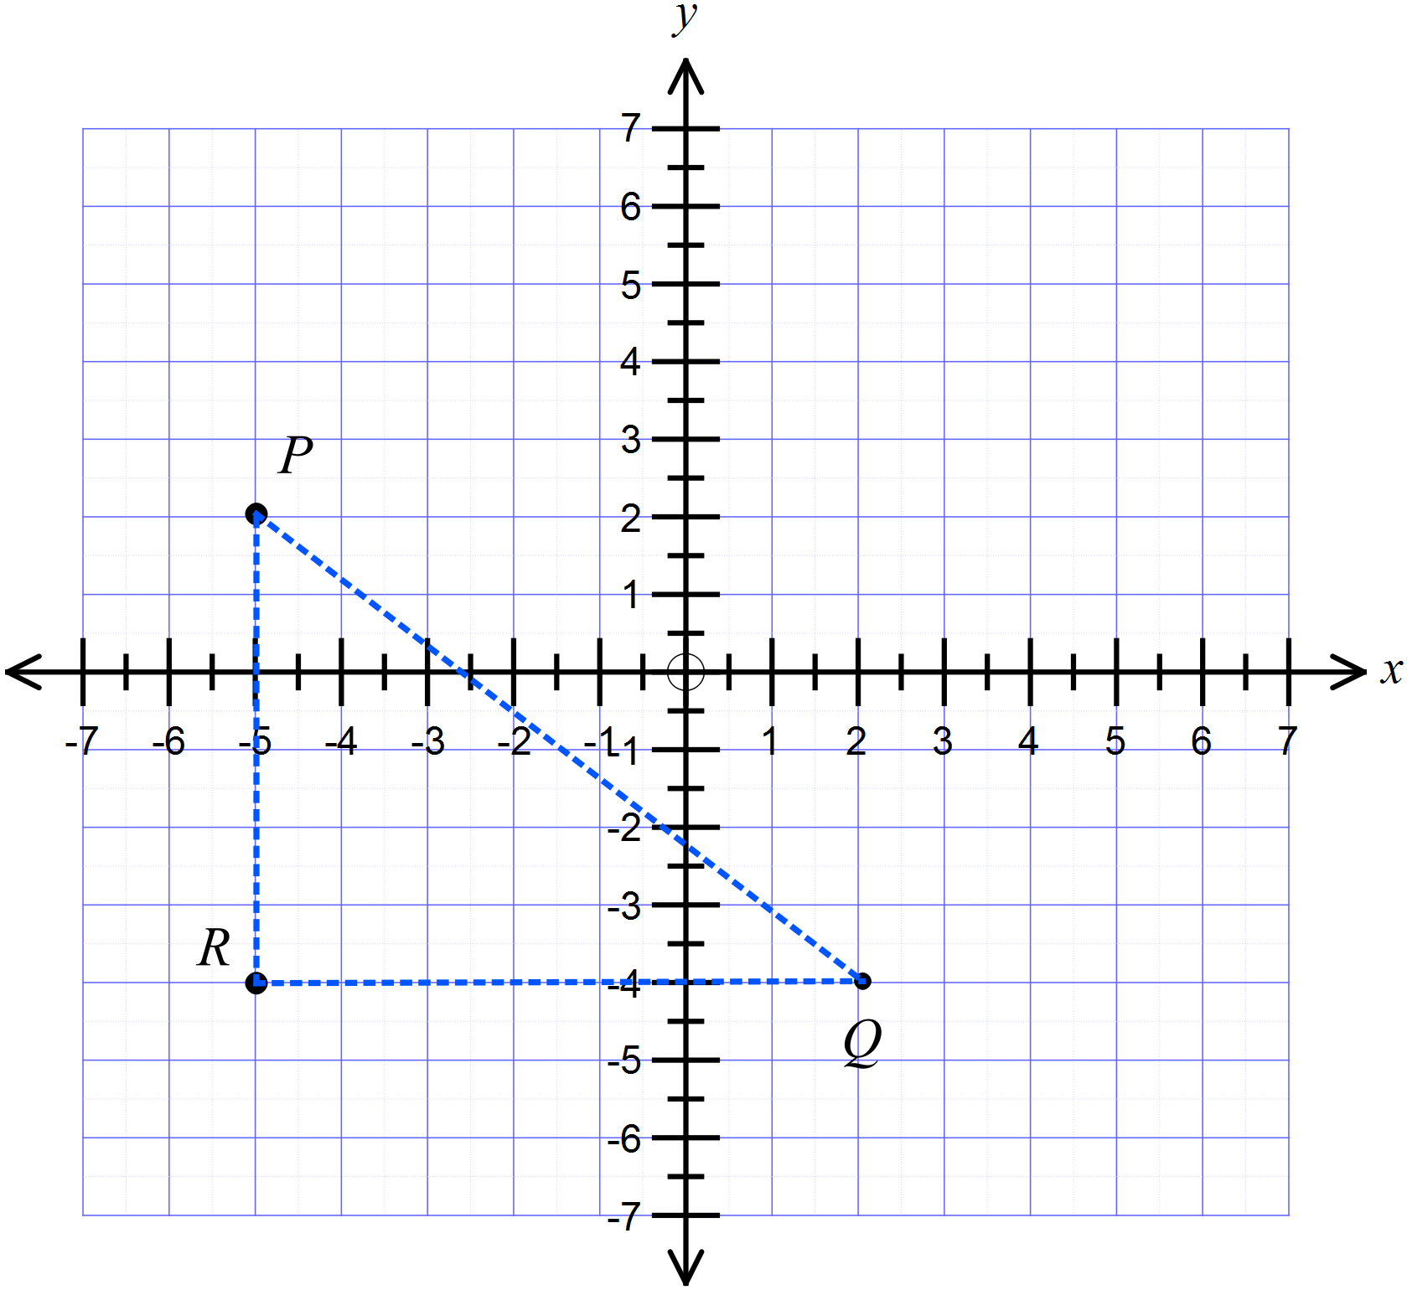Question 1 – 6 refer to the number plane shown.
What are the coordinates of the points P, Q and R?

……………………………………………………………………………………………….
 | Plot and label the points on the number plane above.
What is the area of the triangle PQR?

……………………………………………………………………………………………….

……………………………………………………………………………………………….
What is the midpoint of the interval ST?

……………………………………………………………………………………………….

……………………………………………………………………………………………….
What is the gradient of the interval SU?

……………………………………………………………………………………………….

……………………………………………………………………………………………….
What is the length of the interval TU ?

……………………………………………………………………………………………….

……………………………………………………………………………………………….
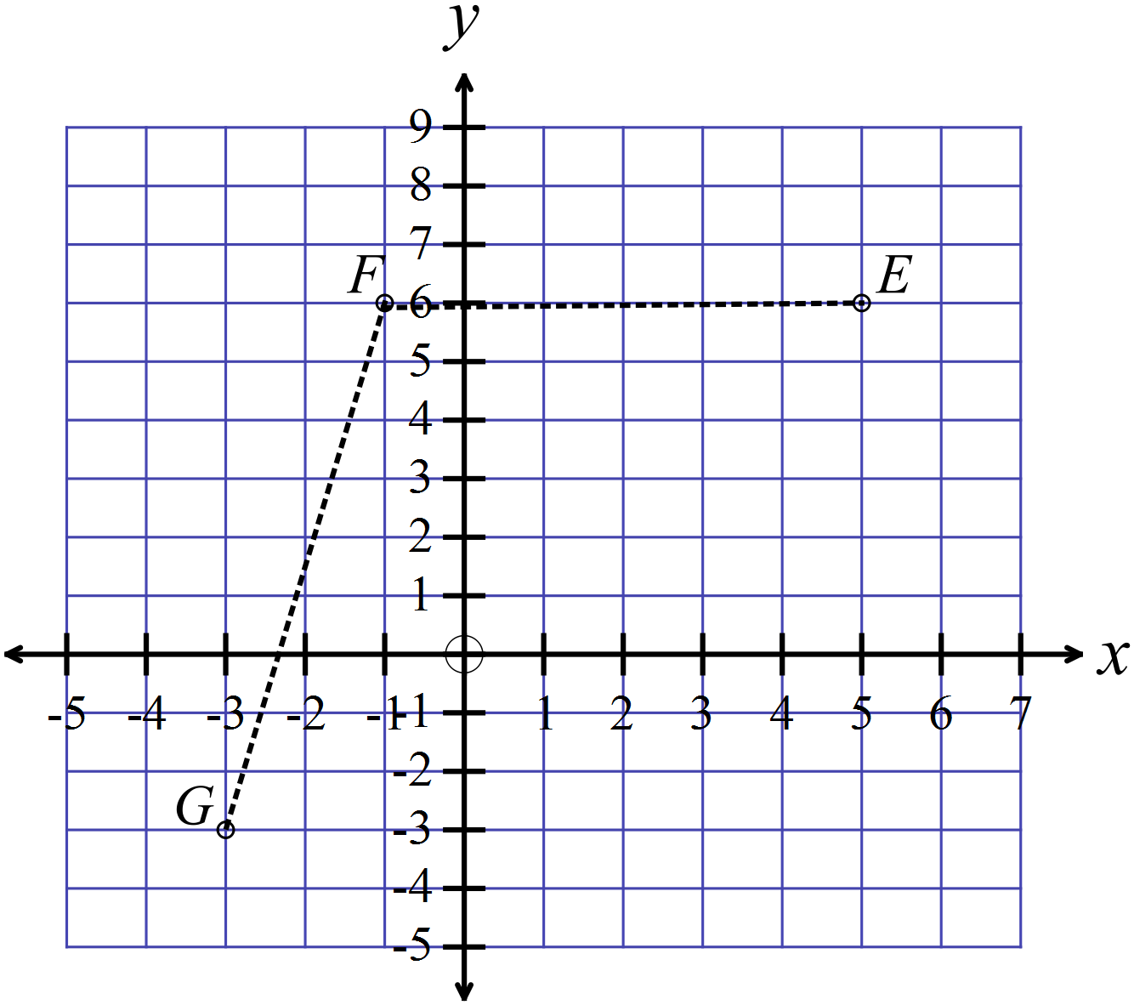The points E, F and G are shown on the number plane.
The point H is the fourth vertex of a parallelogram EFGH.

What are the coordinates of the point H?

.....................................................................

.....................................................................

.....................................................................

What is the midpoint of the interval joining 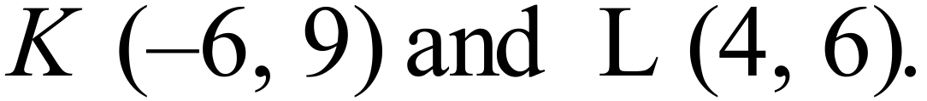

……………………………………………………………………………………………….

……………………………………………………………………………………………….
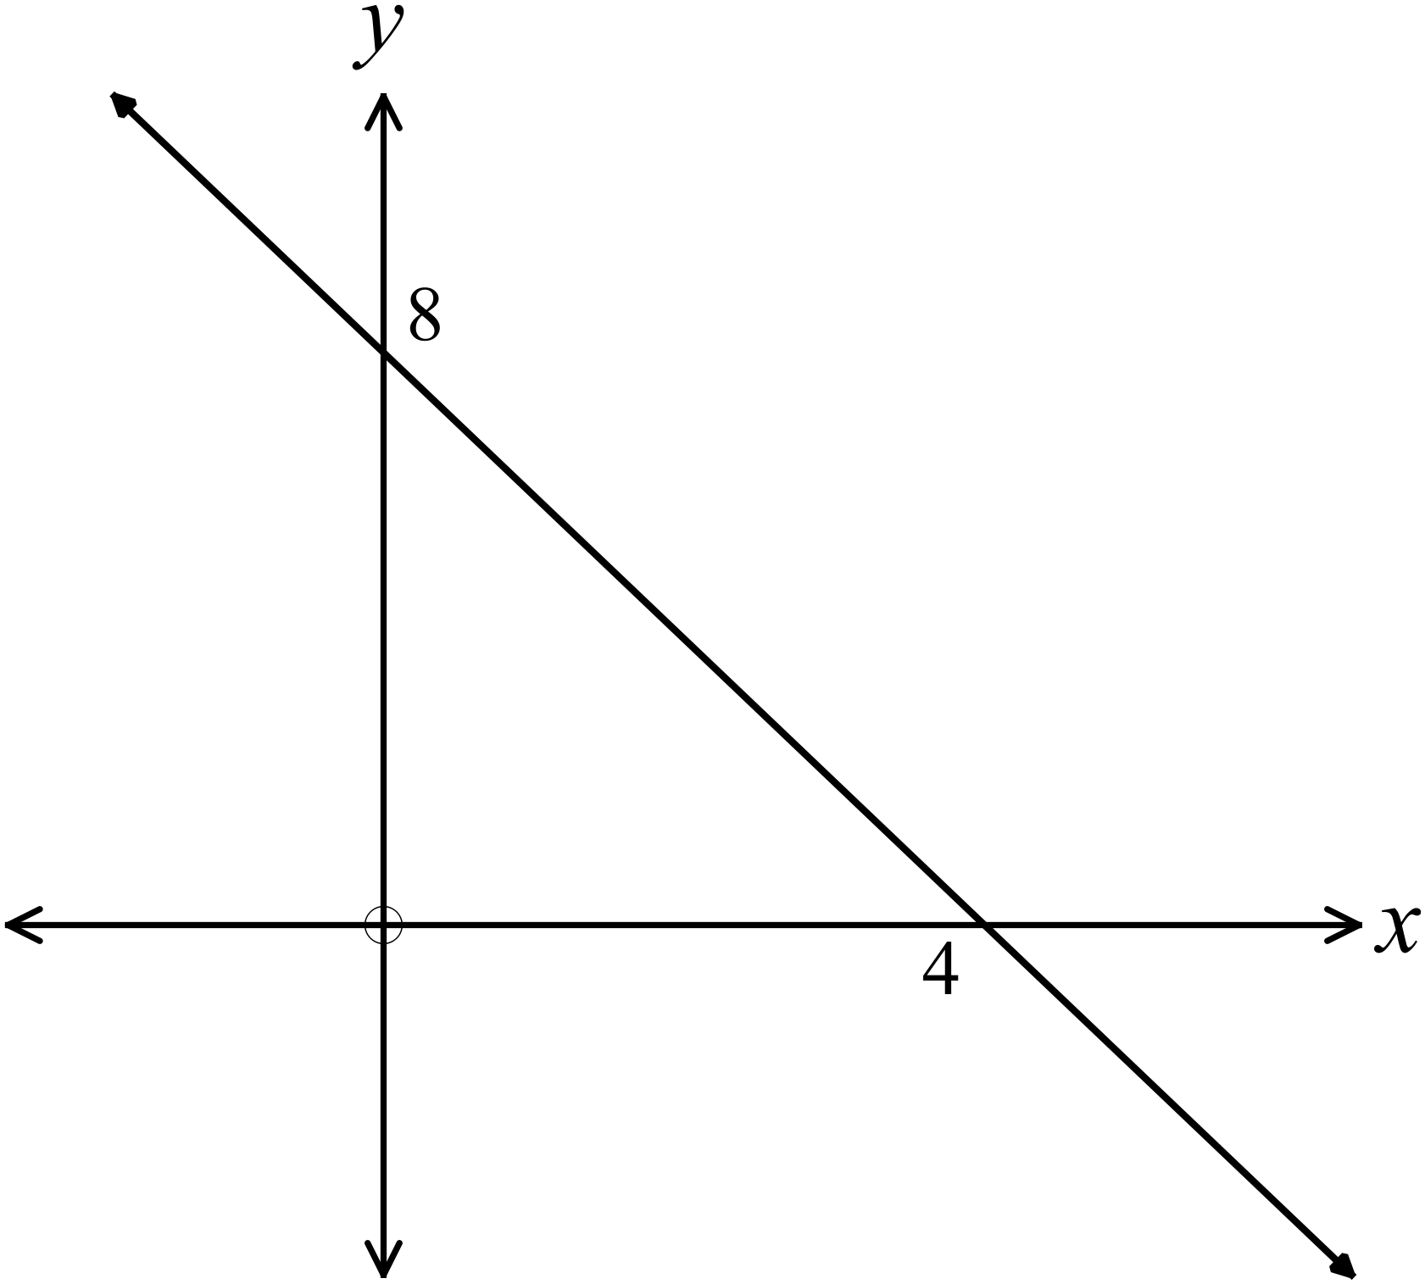What is the gradient of the line shown?

…………………………………………

………………………………………….

…………………………………………

………………………………………….

What is the length of the interval joining 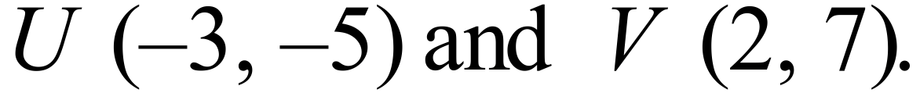

……………………………………………………………………………………………….

……………………………………………………………………………………………….
What is the gradient of the line joining

……………………………………………………………………………………………….

……………………………………………………………………………………………….
What are the values of m and n?

……………………………………………………………………………………………….

……………………………………………………………………………………………….
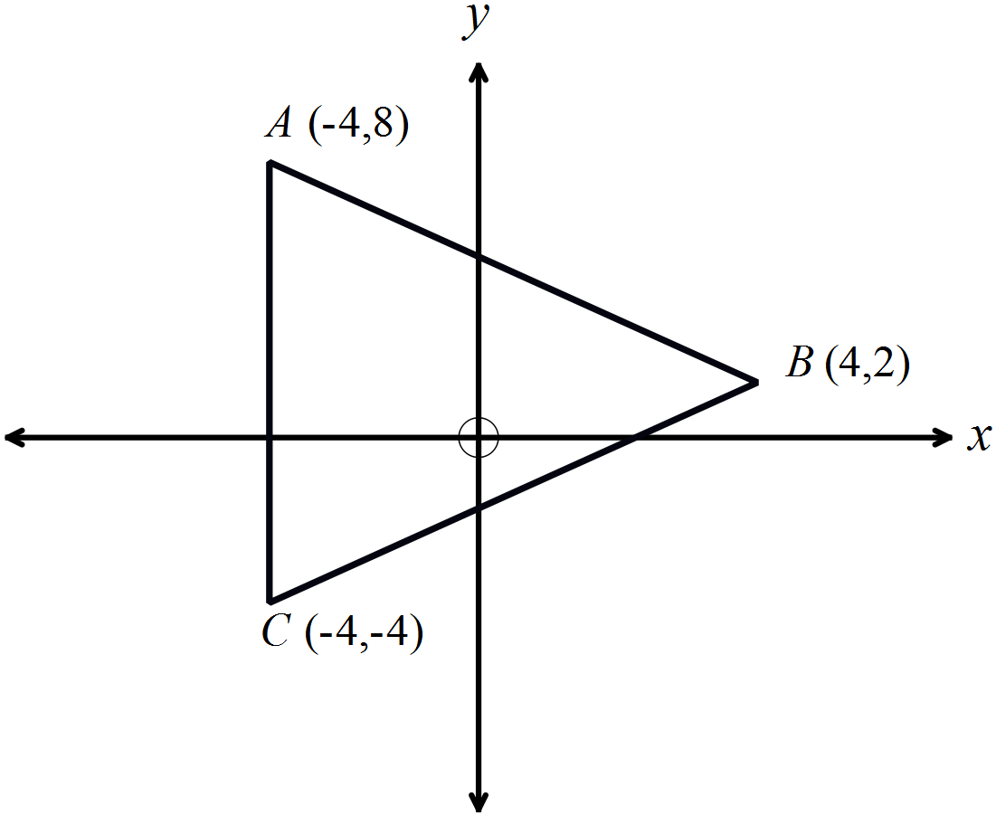Triangle ABC is isosceles, with AB = BC.
Find the perimeter of the triangle.

……………………………………………

……………………………………………

……………………………………………

……………………………………………
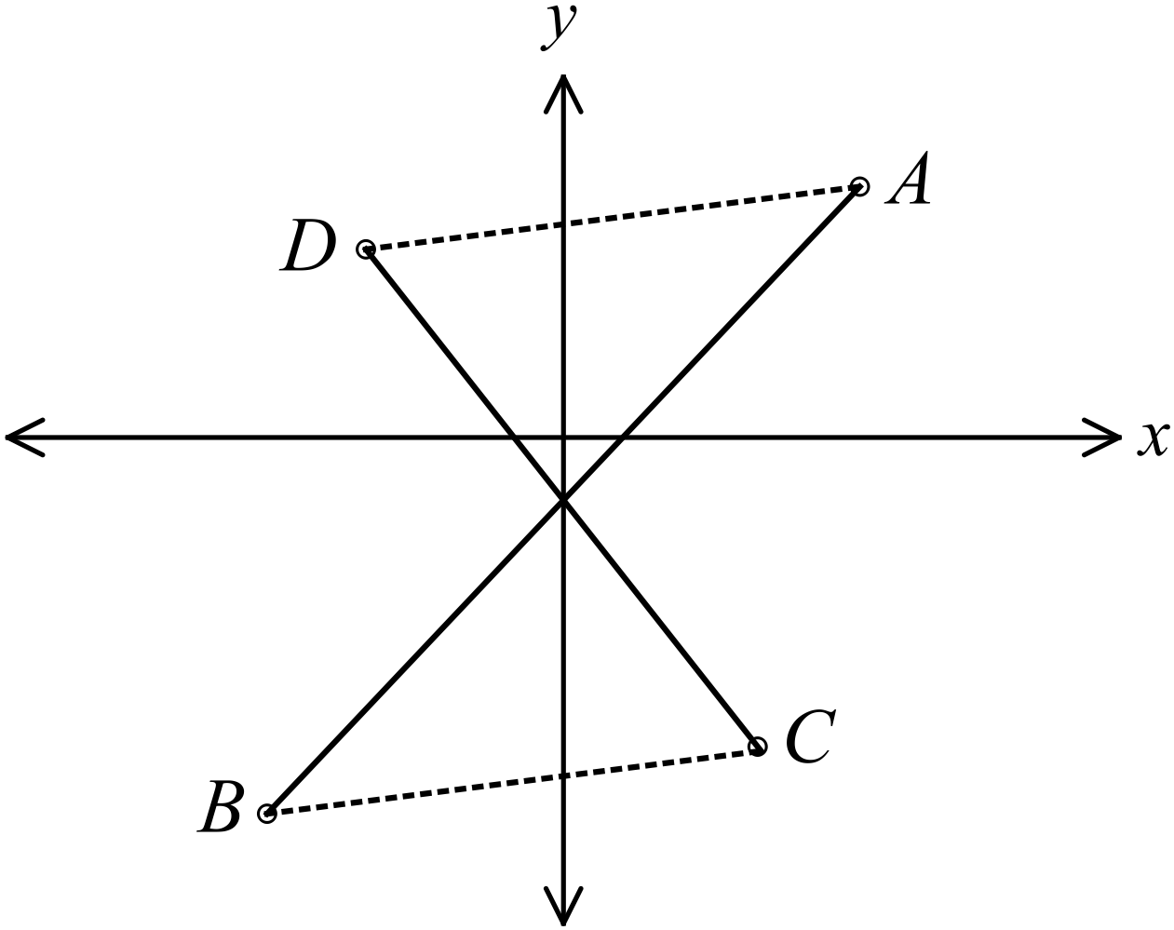Questions 14 and 15 refer to the diagram below.

The points A (6, 4), B (-6, -6), C (4, -5) and
D (-4, 3) are shown on the number plane.

Show that the interval CD bisects the interval AB.

………………………………………………………………………………………….

………………………………………………………………………………………….

………………………………………………………………………………………….
Show that the interval AD is parallel to the interval CB.

………………………………………………………………………………………….

………………………………………………………………………………………….

Year 9 |  | Coordinate Geometry | Calculator Allowed
 |  | Coordinate Geometry | Name_________________
Section 2 Multiple Choice Section
Mark all your answers on the accompanying multiple choice answer sheet, not on this test paper. You may do any working out on this test paper. Calculators are allowed for this section.

Questions 1 and 2 refer to the number plane below.
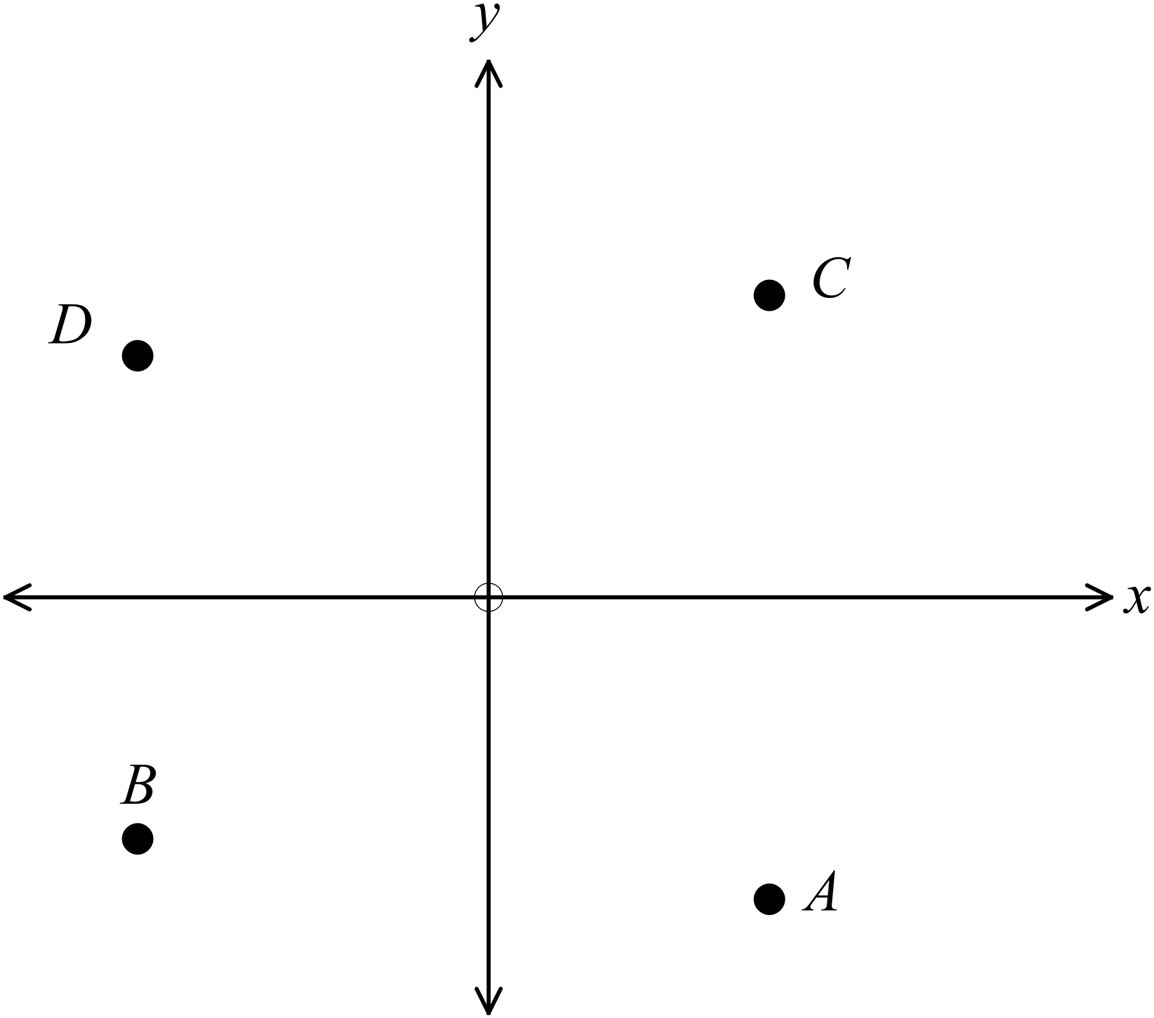

Which of the points lies in the 3rd quadrant of the number plane?

A. Point A B. Point B C. Point C D. Point D
Which of the points could have coordinates (4, -5)?

A. Point A B. Point B C. Point C D. Point D
What is the midpoint of the interval joining (9, 4) and (5, 0)?

A. (2, 2) B. (4, 4) C. (7, 2) D. (14, 4)
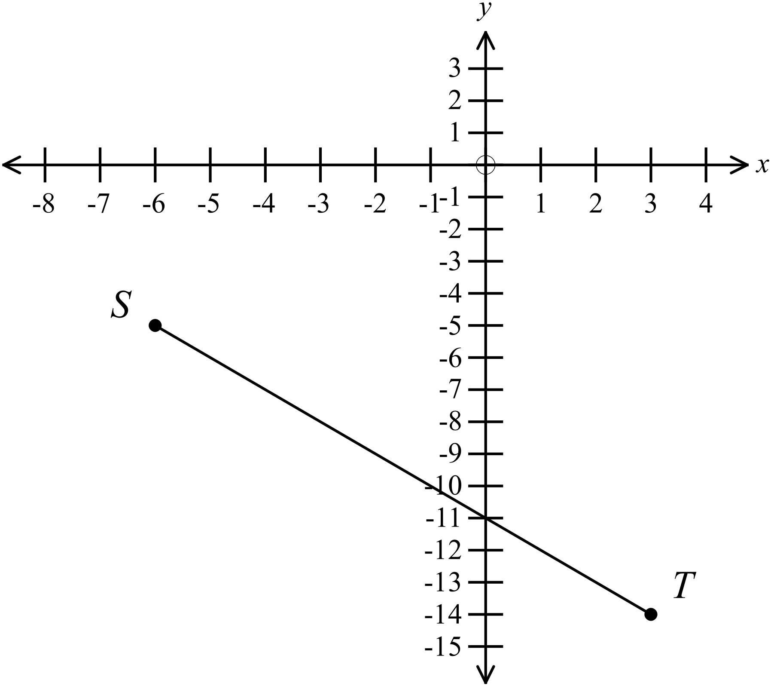
What is the gradient of the line ST?

A. 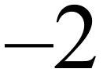
B. 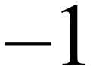
C. 
D. 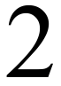

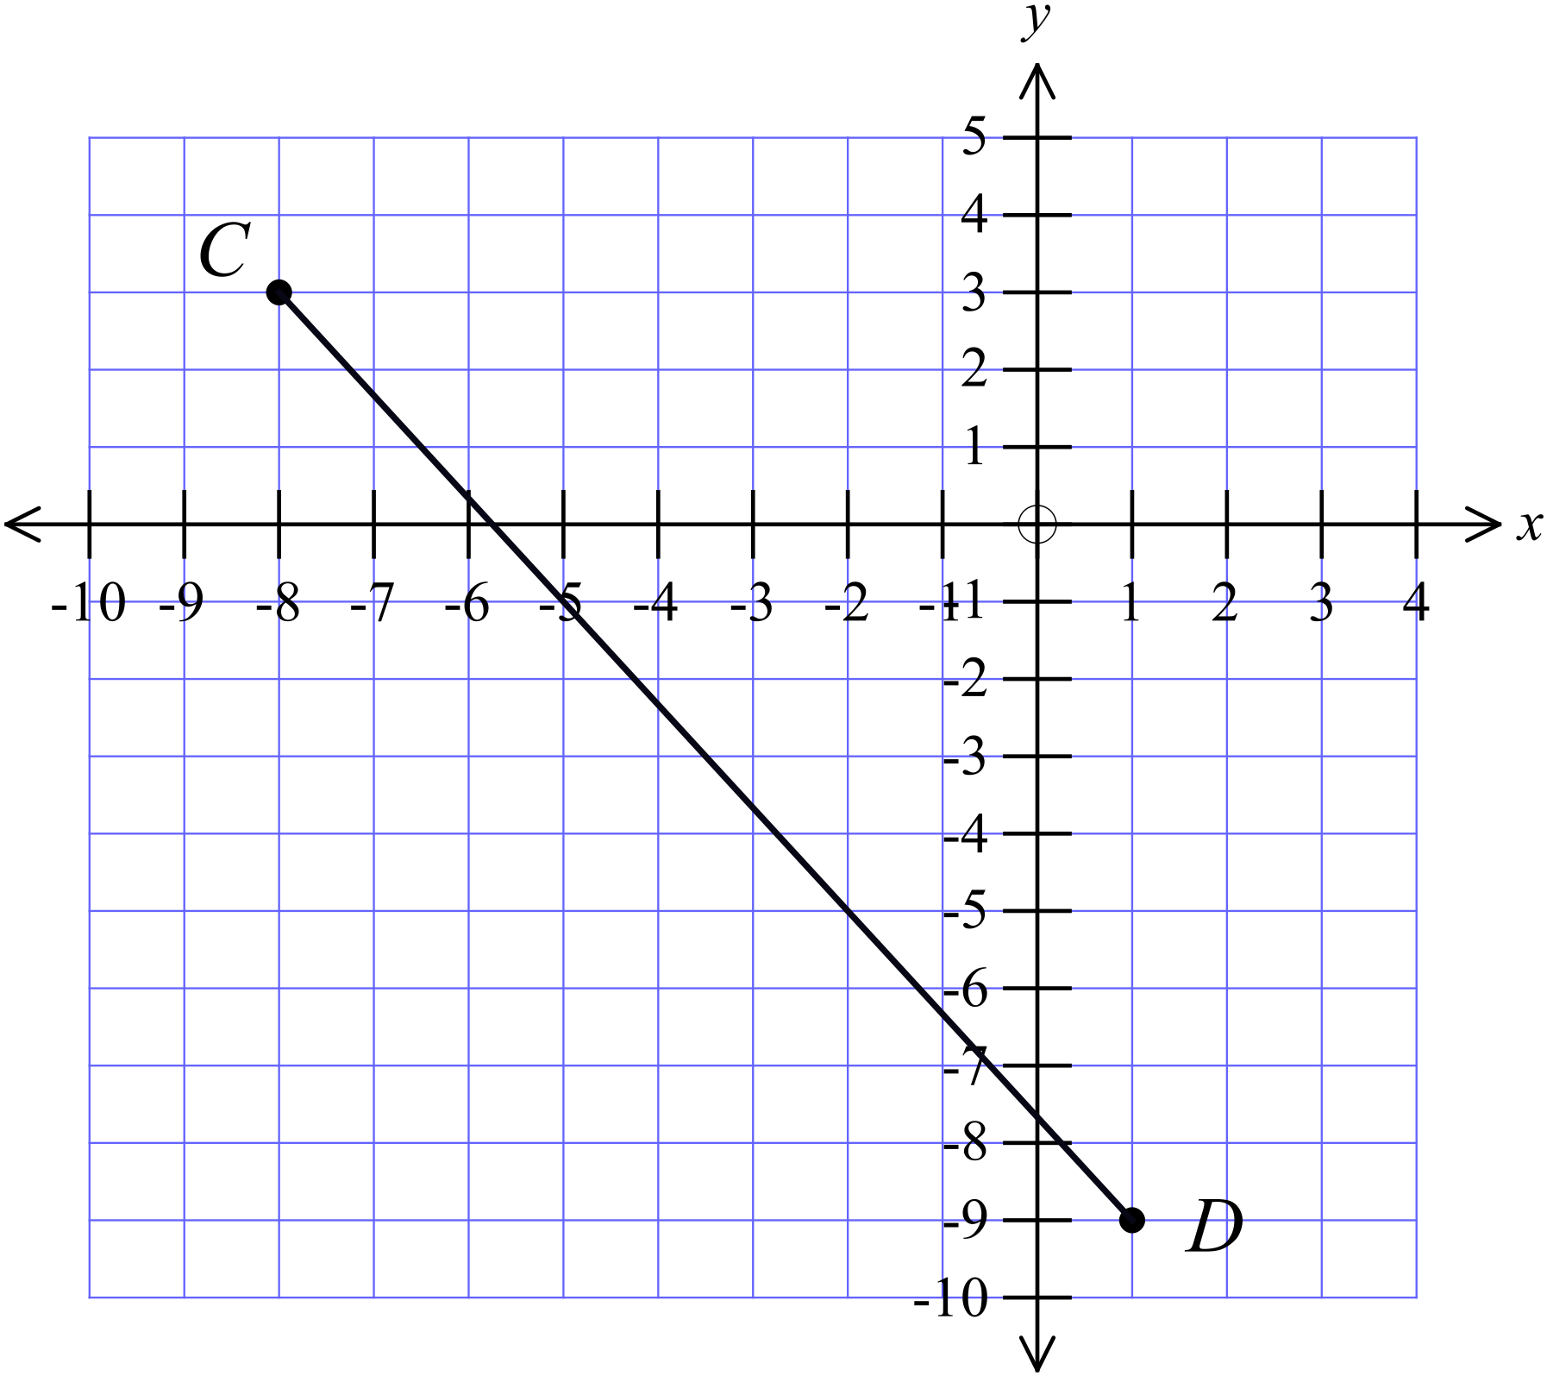What is the distance between the points C(-8, 3) and D(1, -9)?

A. 9 cm
B. 12 cm
C. 13 cm
D. 15 cm
Questions 6 – 8 refer to the number plane shown.
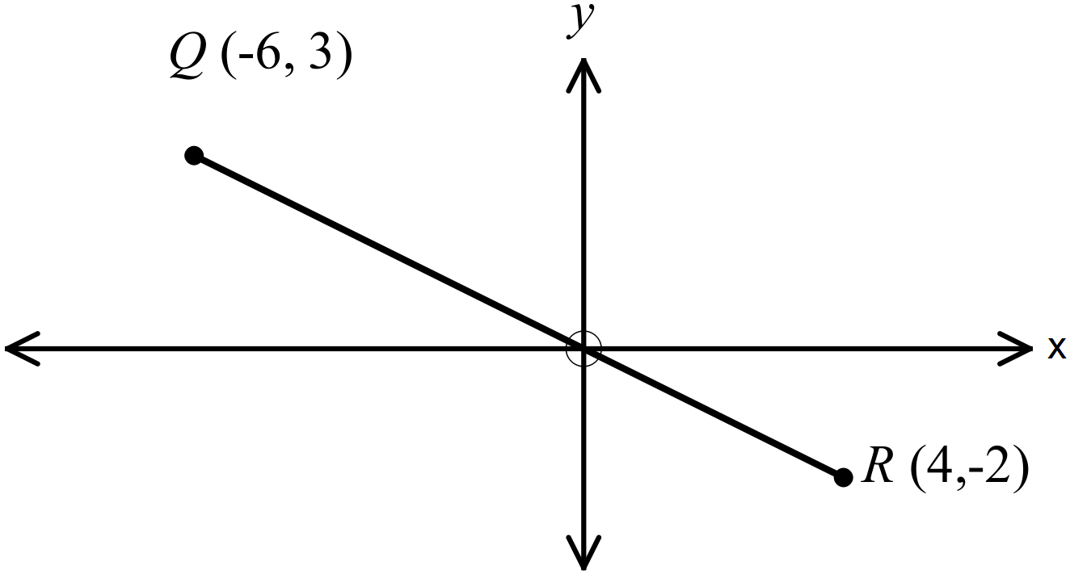

Find the midpoint of the interval QR.

A. 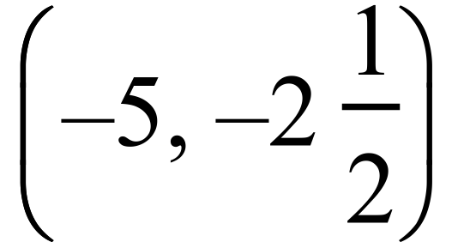 B. 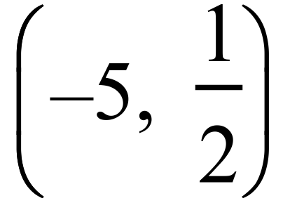 C. 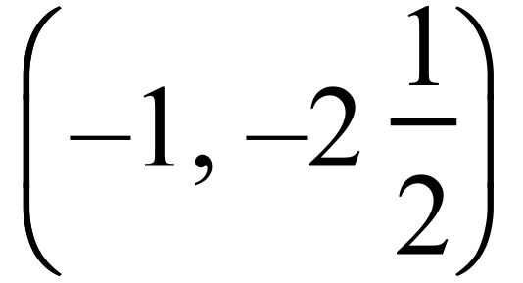 D. 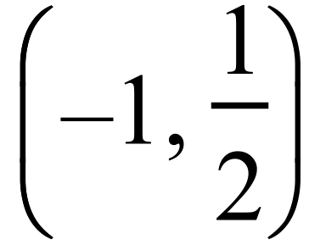
What is the gradient of the interval QR?

A. B. 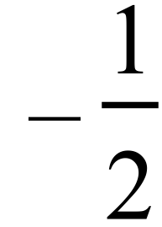 C.  D. 2
What is the length of the interval QR?

A. 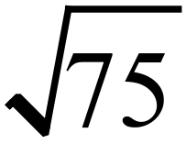 units B. 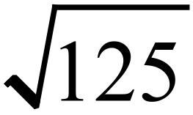 units C. 12.5 units D. 62.5 units
Find the gradient of the interval joining D(3, -1) and E(-3, 2).

A. 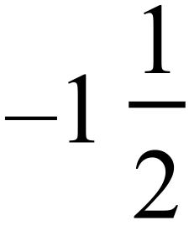 B. 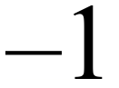 C. 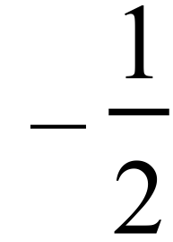 D. 
Find the length of the interval joining G(-2, -5) and H(-6, 7).

A.  B. 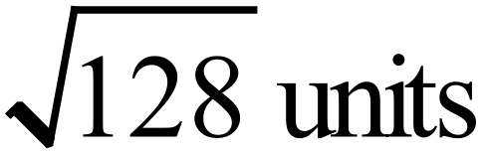 C.  D. 
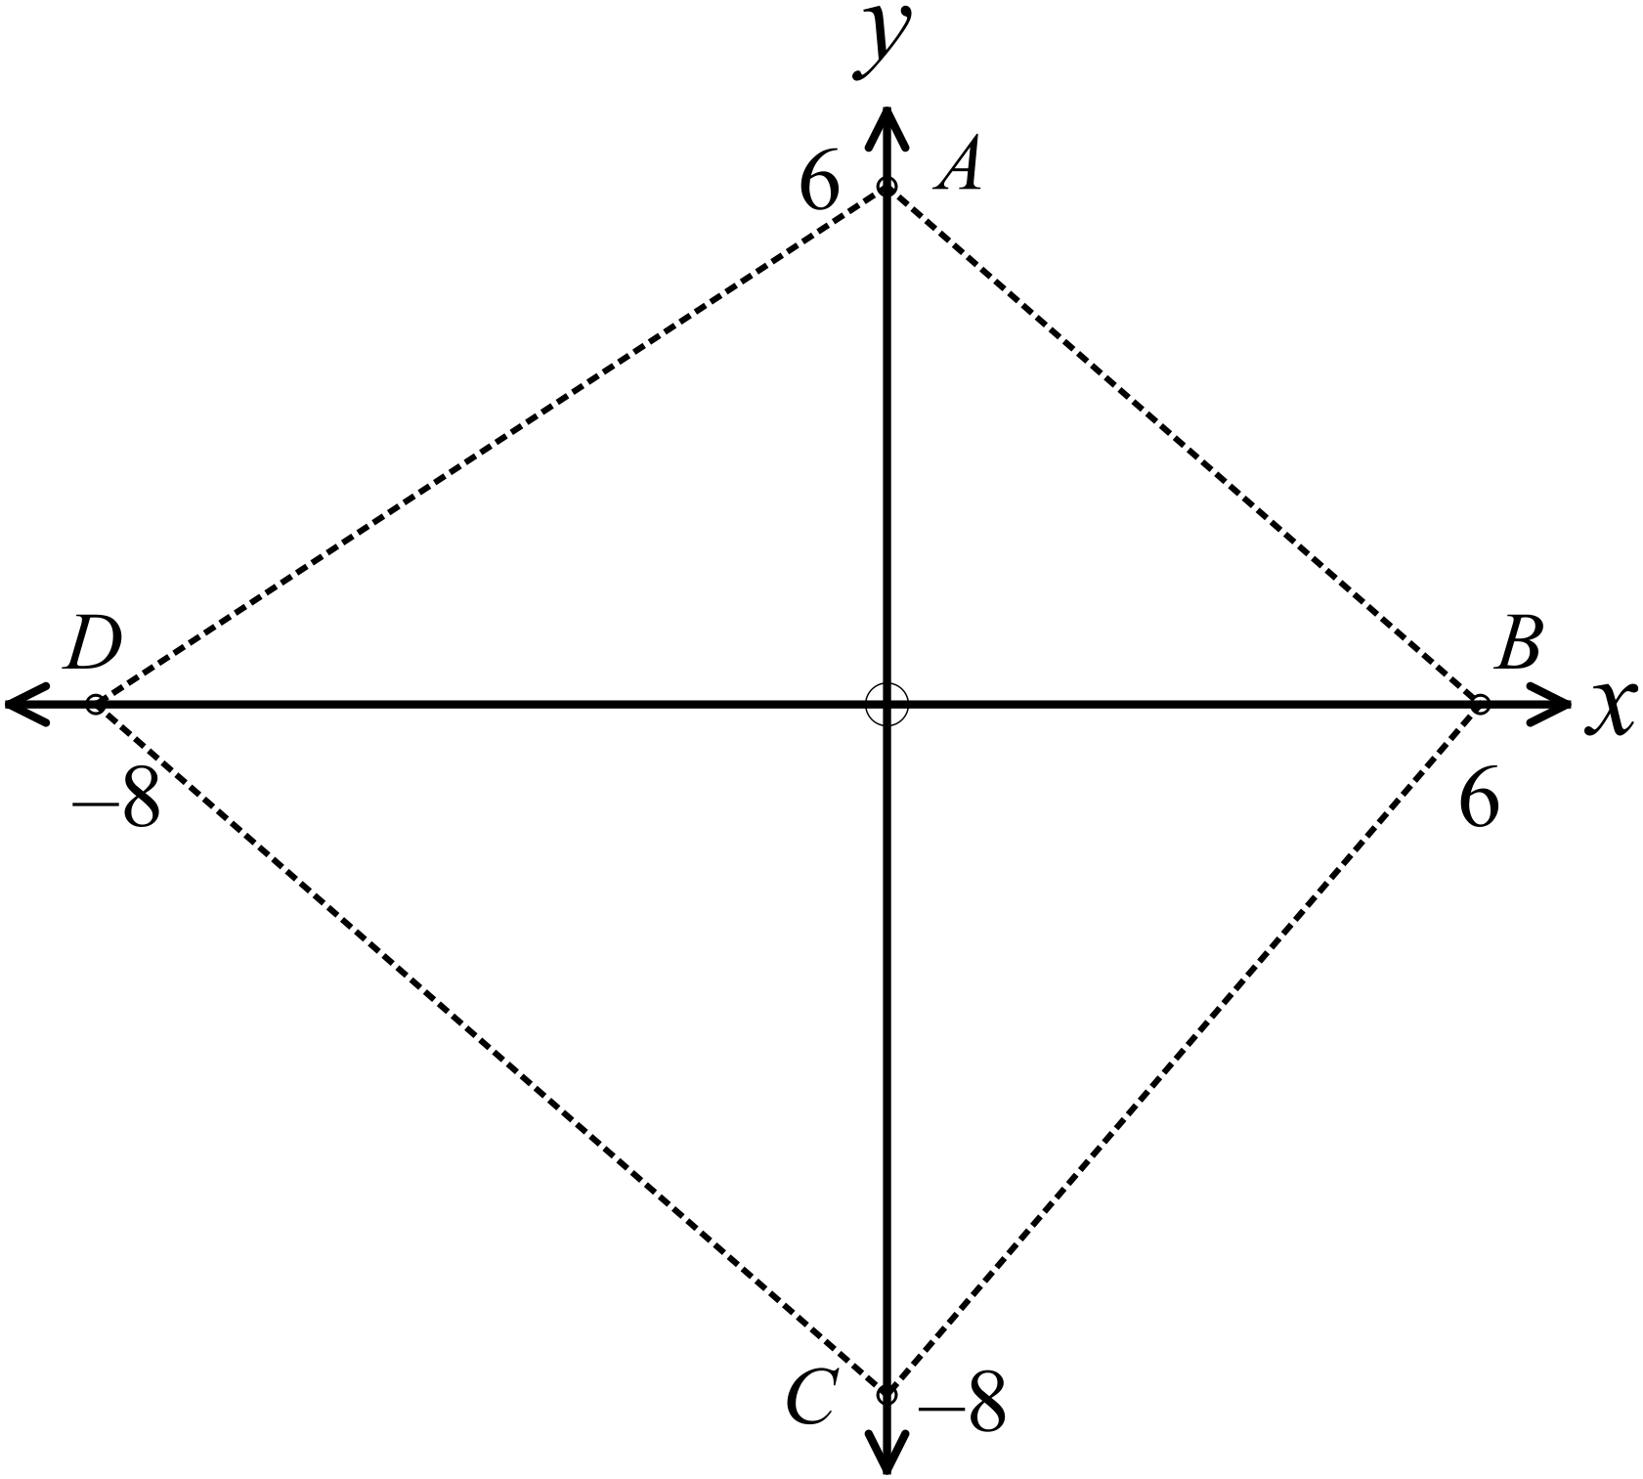Which two intervals are the same length?

A. 

B. 

C. 

D. 
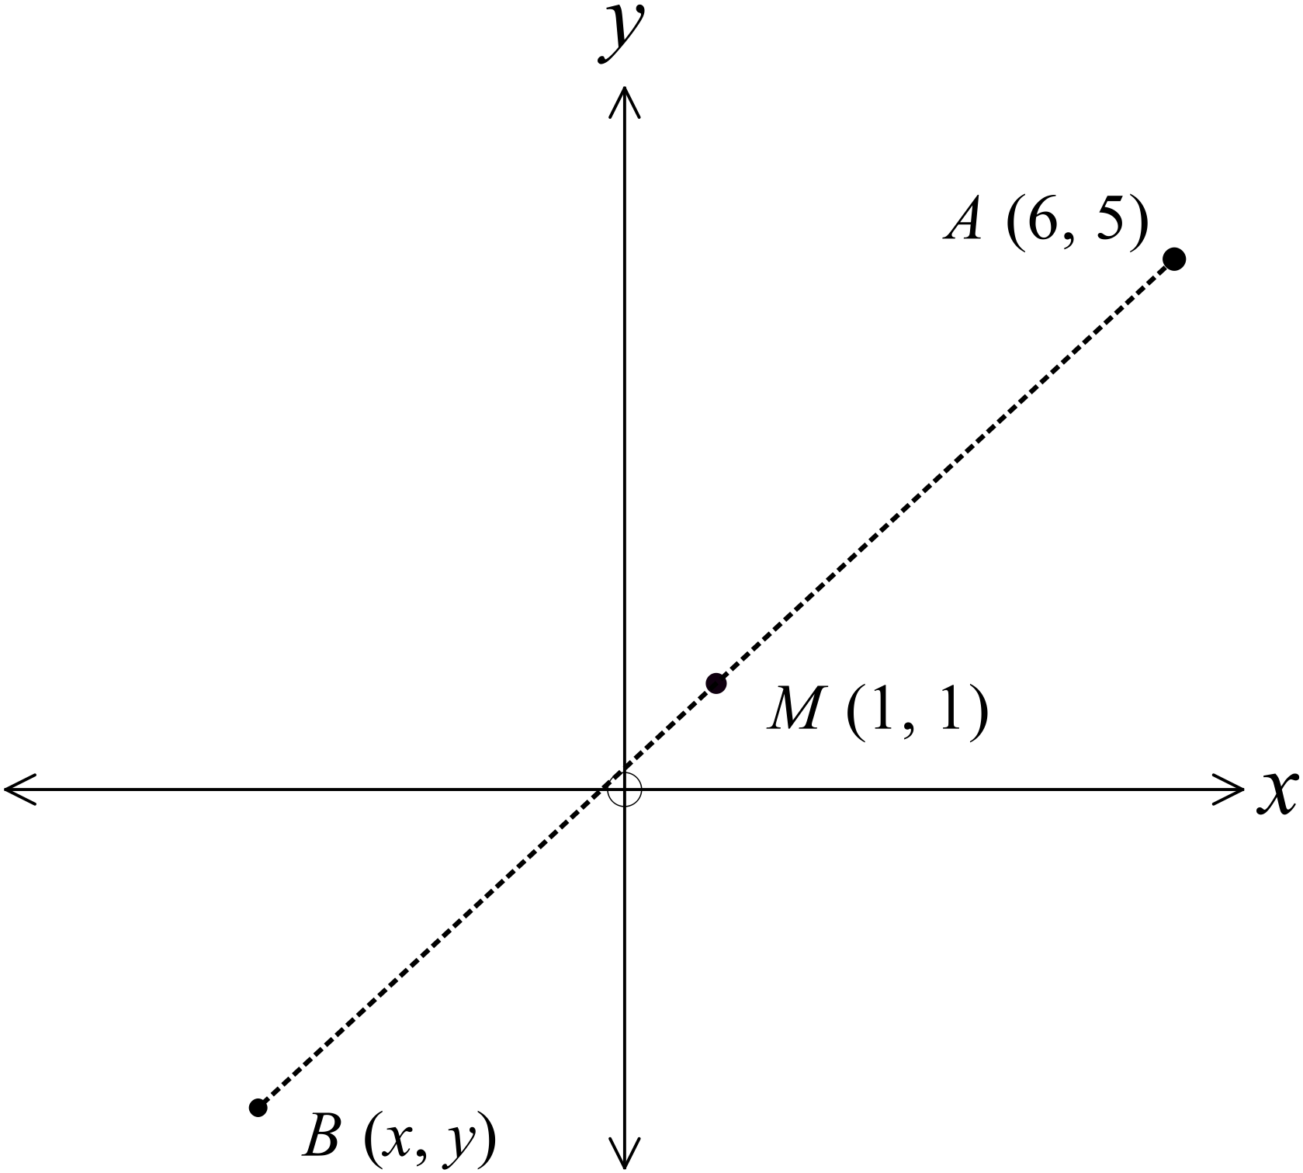M (1, 1) is the midpoint of the interval AB.
D has coordinates (6, 5).
What are the coordinates of B?

A. 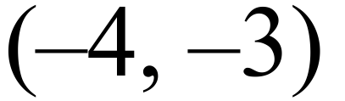

B. 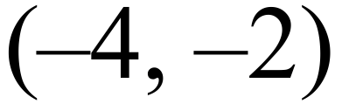

C. 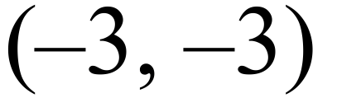

D. 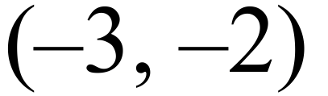
Given the points , which statement is true?

A. Point A bisects the interval DC.
B. Point C bisects the interval BE.
C. Point D bisects the interval BC.
D. Point D bisects the interval BE.

The interval LM has a gradient of 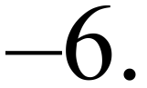
If L is the point (2, 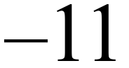 ), which of the following could be the coordinates of M?

A. 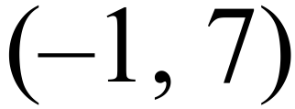 B. 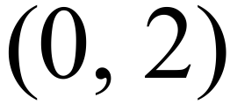 C. 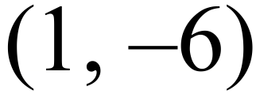 D. 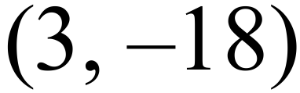
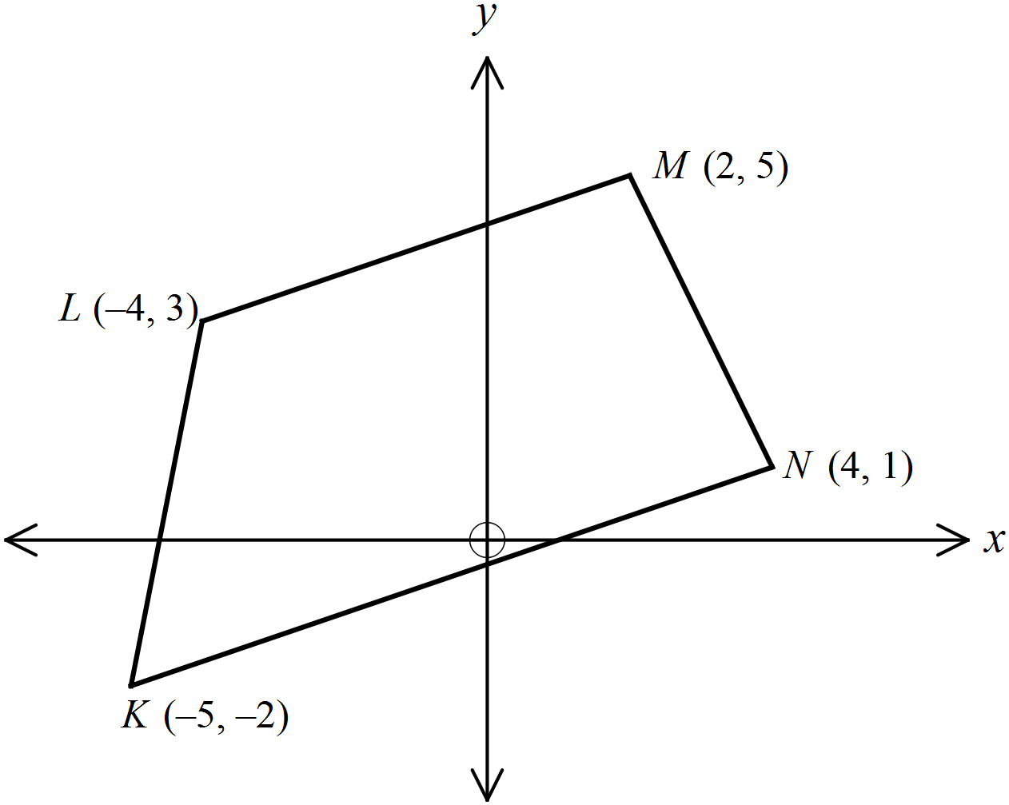The quadrilateral KLMN has a pair of parallel sides.
What is the gradient of these sides?

A.
B. 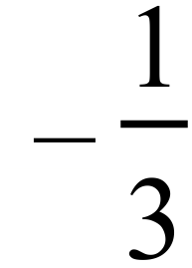
C. 
D. 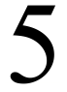

Multiple Choice Answer Sheet
Coordinate Geometry
Name _____________________________________________
Completely fill the response oval representing the most correct answer.

1. A B C D
2. A B C D
3. A B C D
4. A B C D
5. A B C D
6. A B C D
7. A B C D
8. A B C D
9. A B C D
10. A B C D
11. A B C D
12. A B C D
13. A B C D
14. A B C D
15. A B C D
Year 9 |  | Coordinate Geometry | Non Calculator
Section 1 Short Answer Section
ANSWERS
No. | WORKING |  | ANSWER
 | 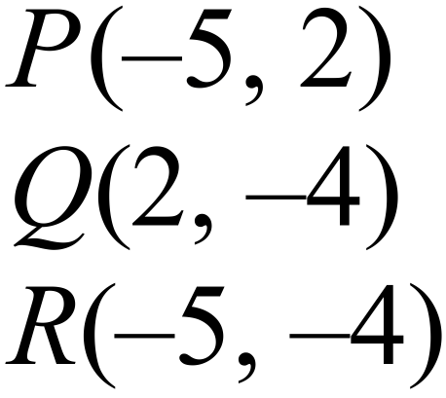
 | 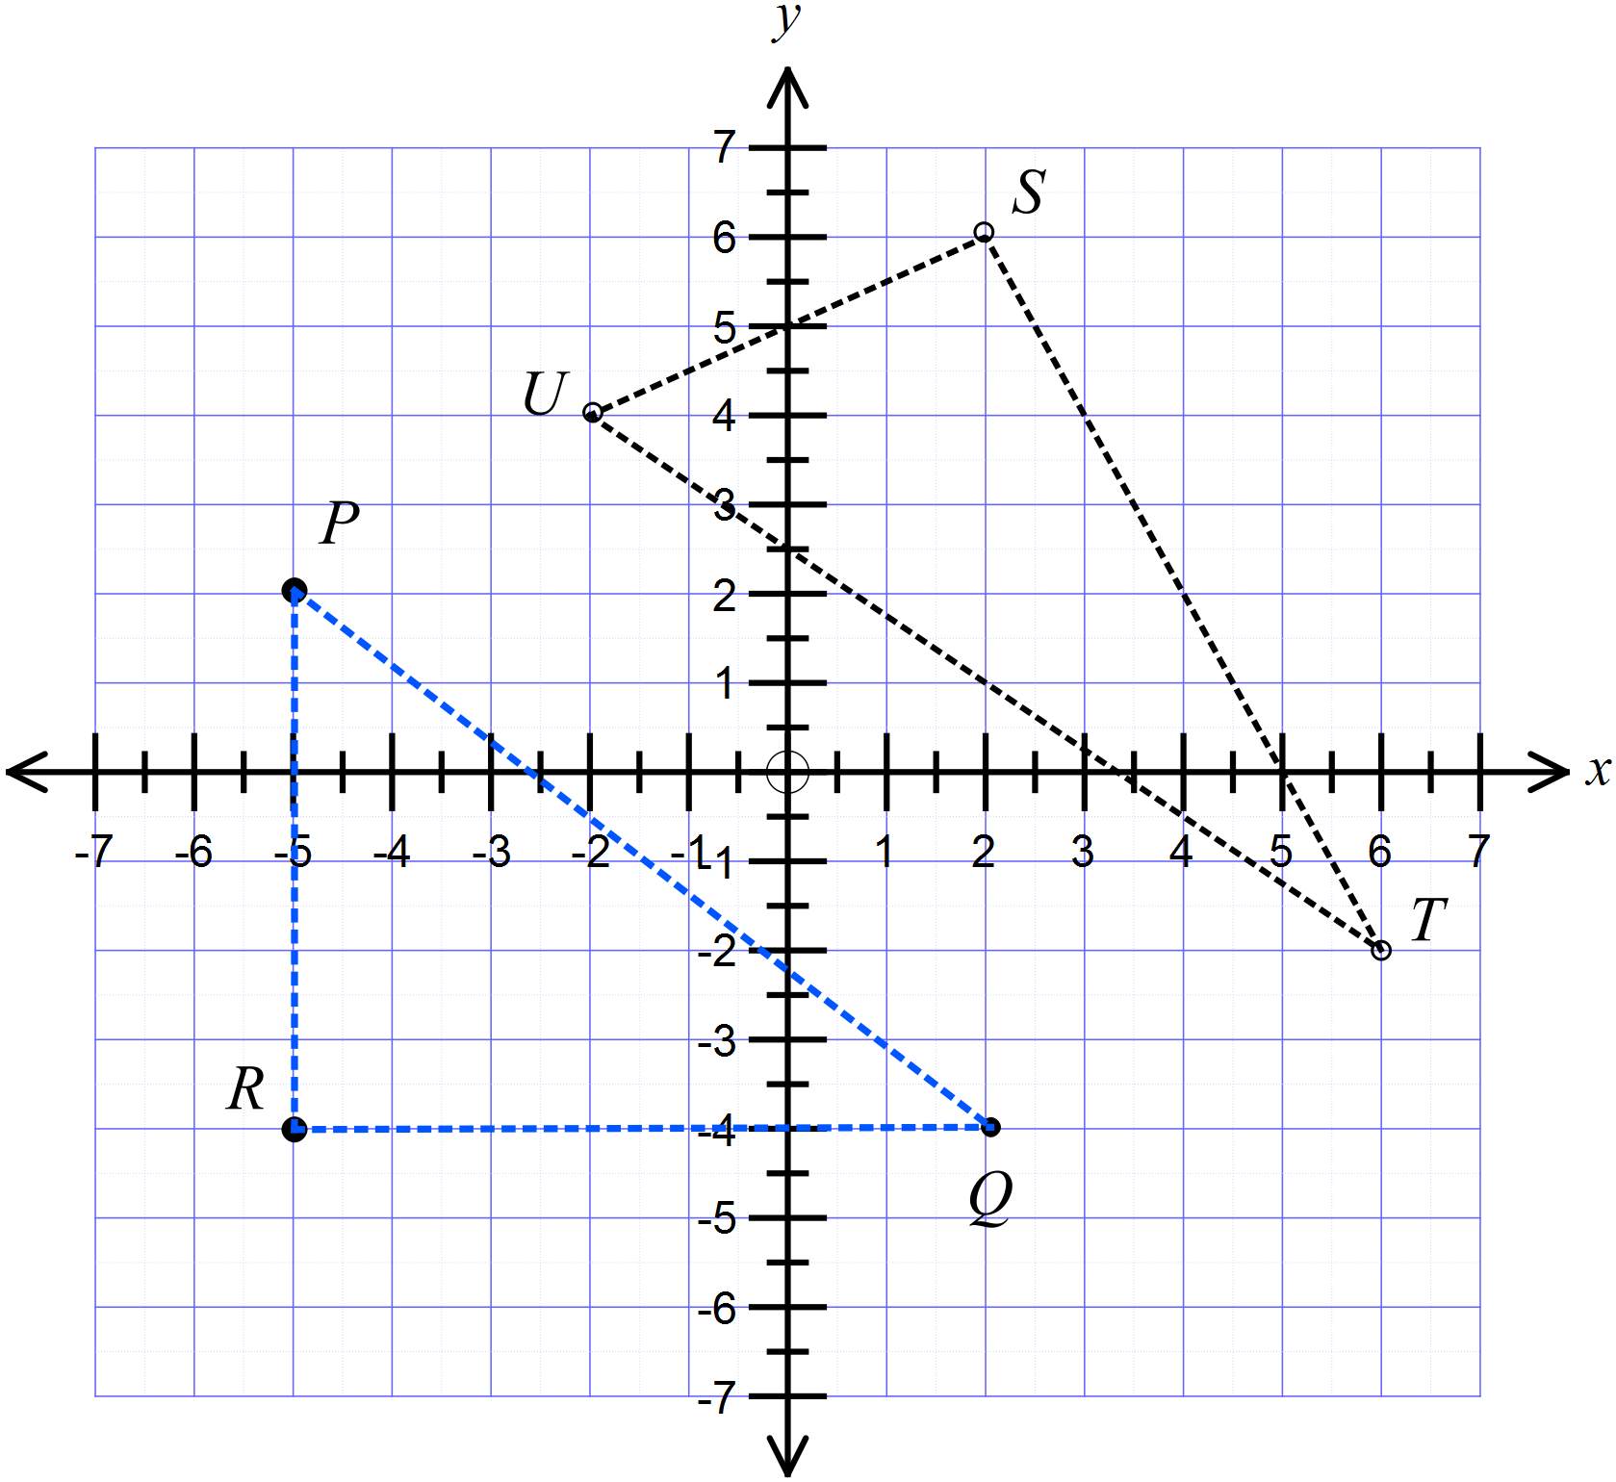 |  | Points S, T and U on the graph as shown.
 | Base RQ = 7  Height PR = 6  Area = 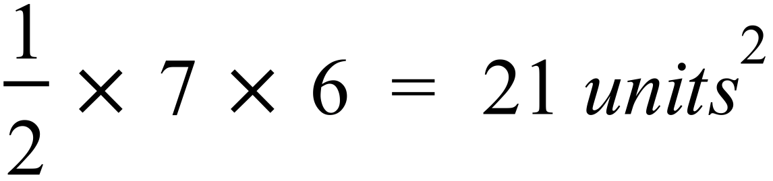 |  | 21 units²
 | 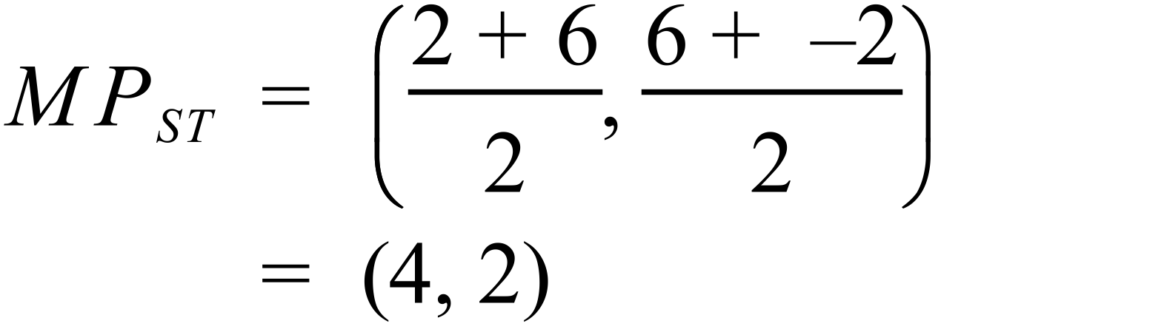 |  | 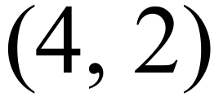
 | 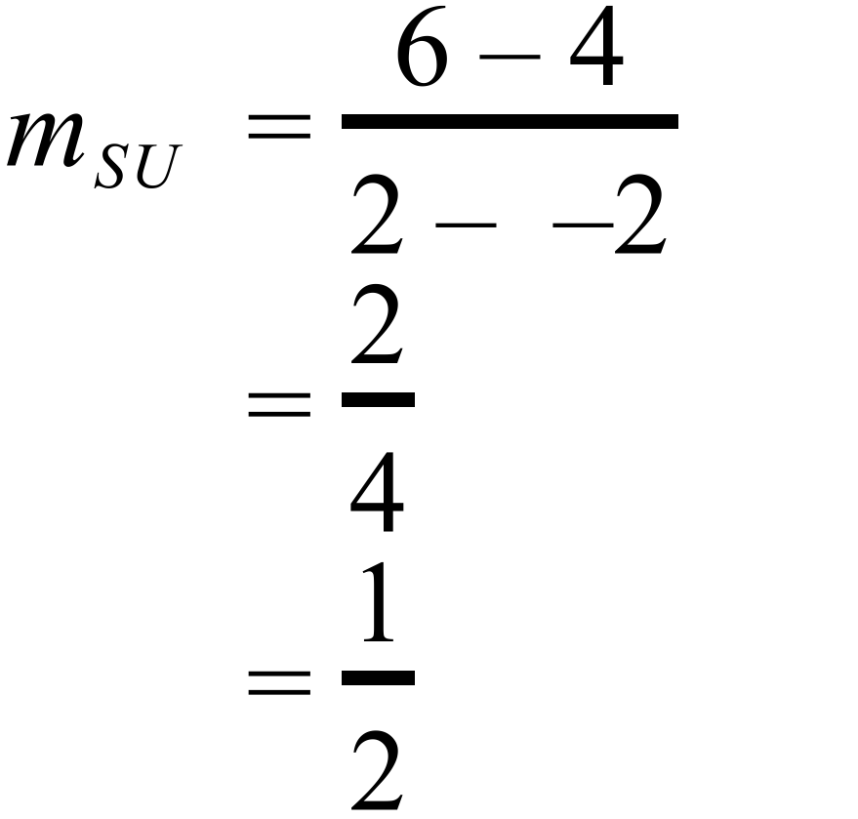 |  | 
 | 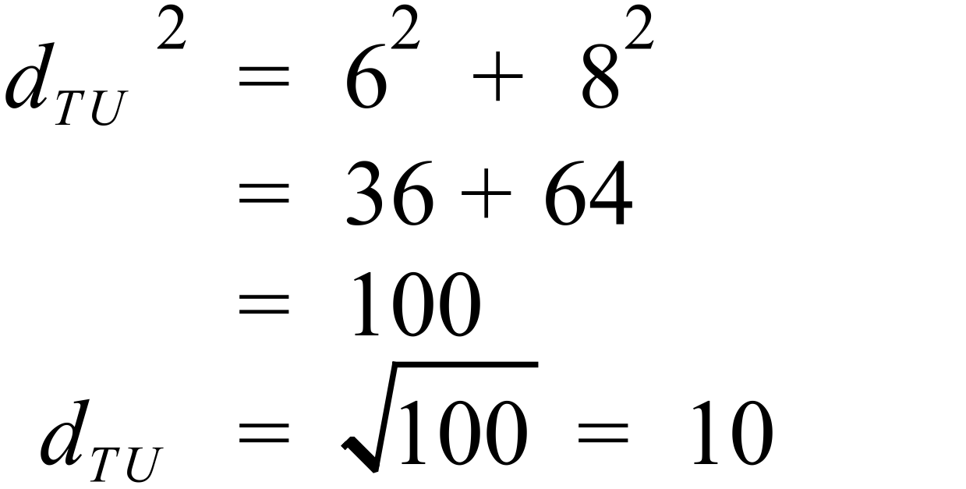 |  | 10 units
 | 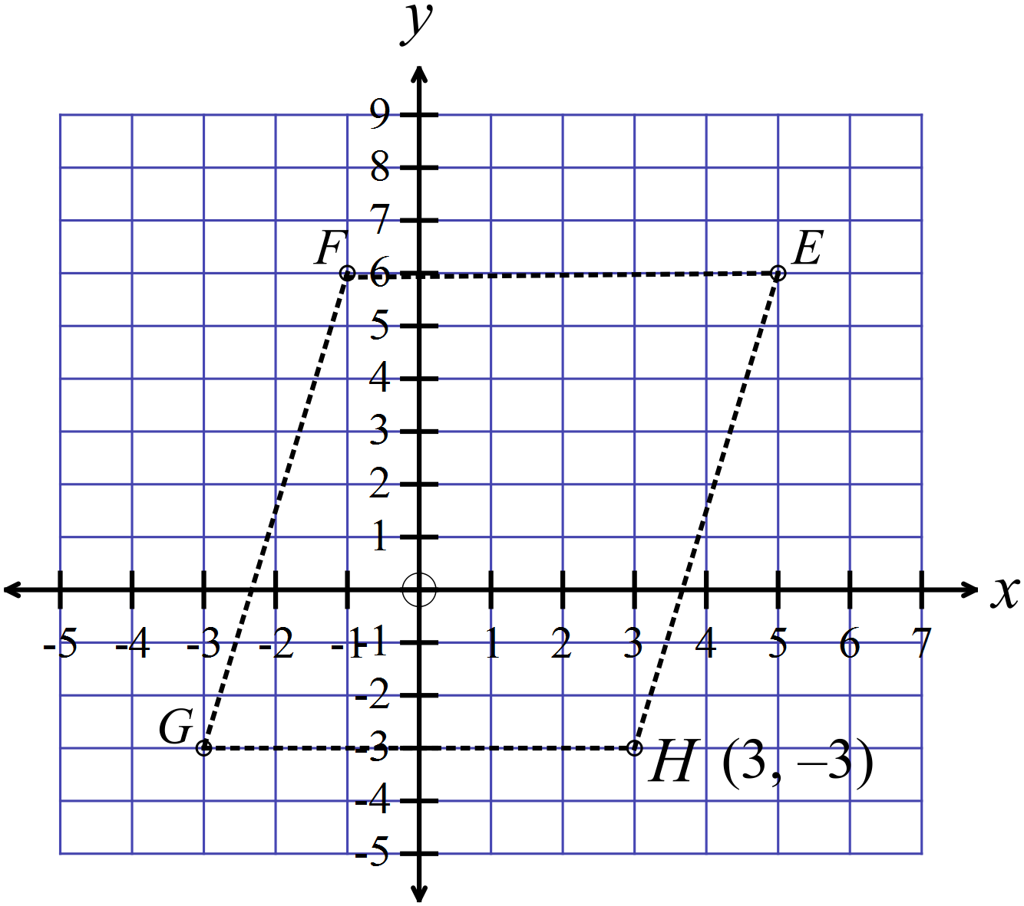 |  | 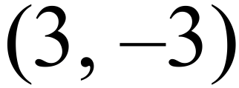
 | Midpoint of  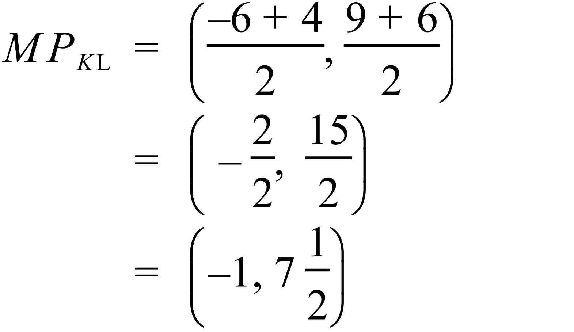 |  | 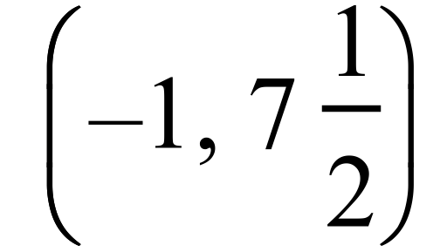
 | 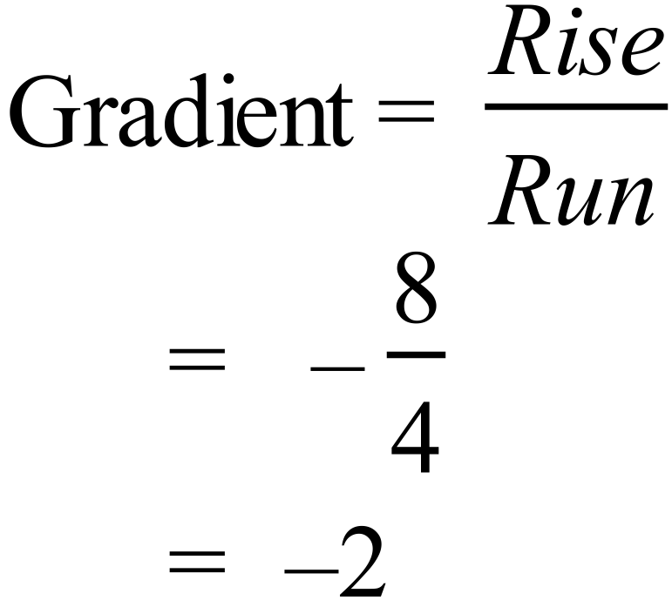
 | Distance from 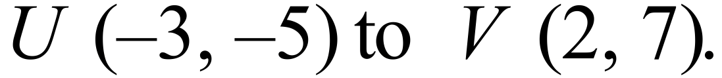  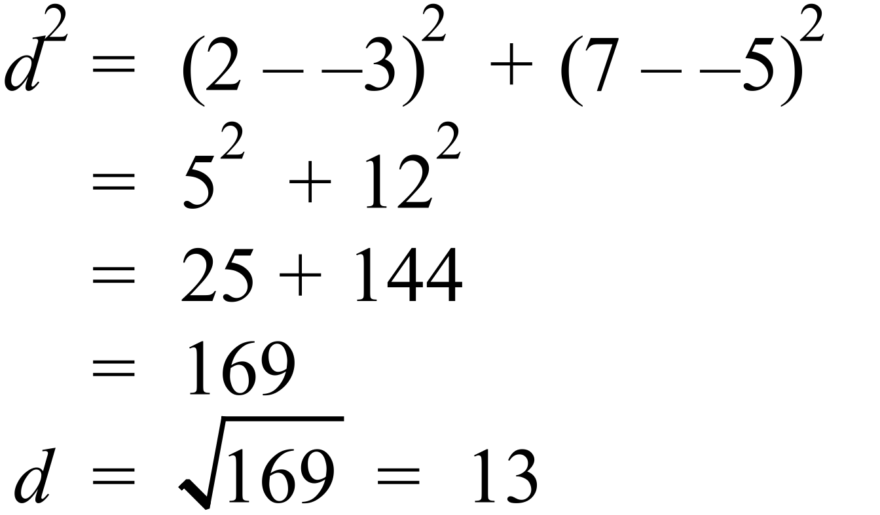 |  | 13
Gradient of the line joining
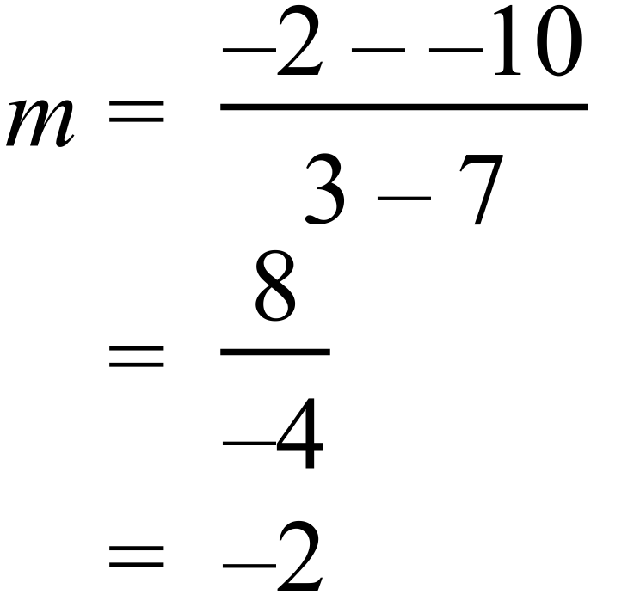
 | 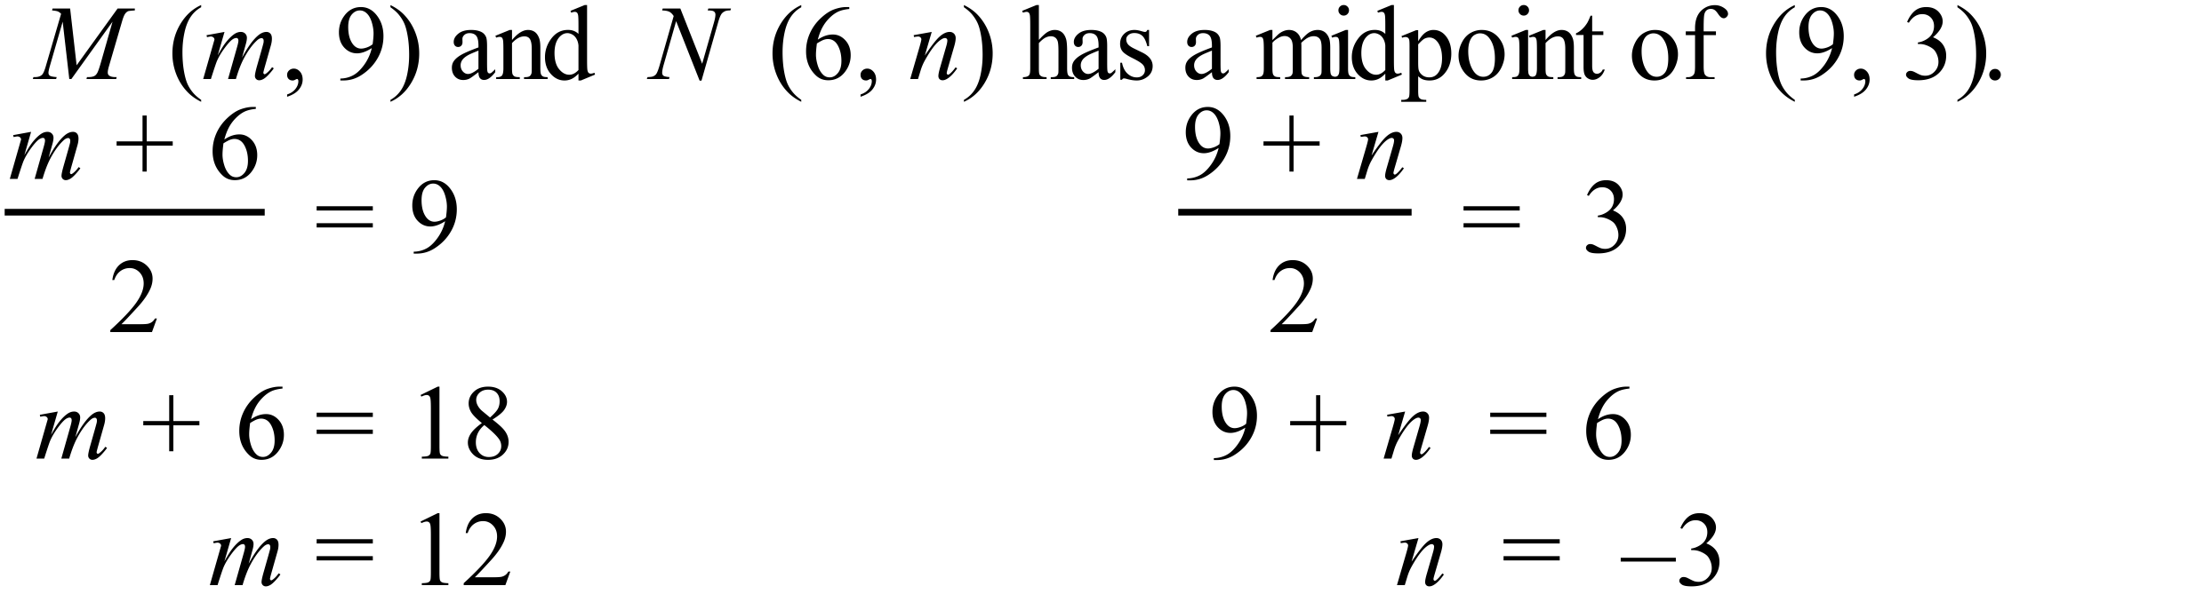 |  | 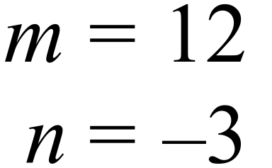
 | 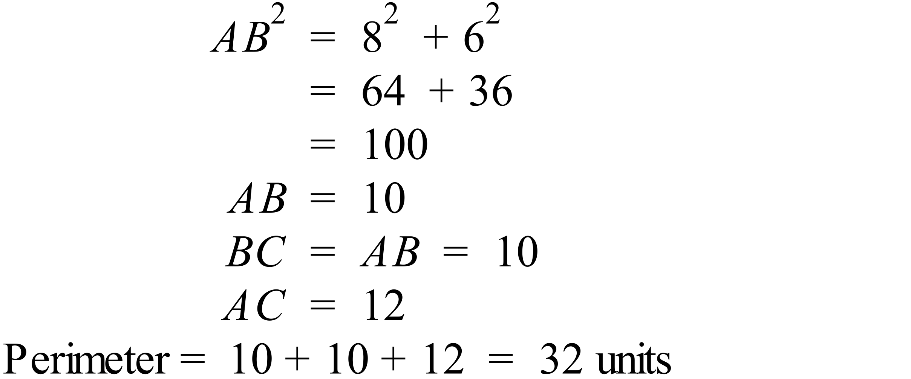 |  | 32 units
 | 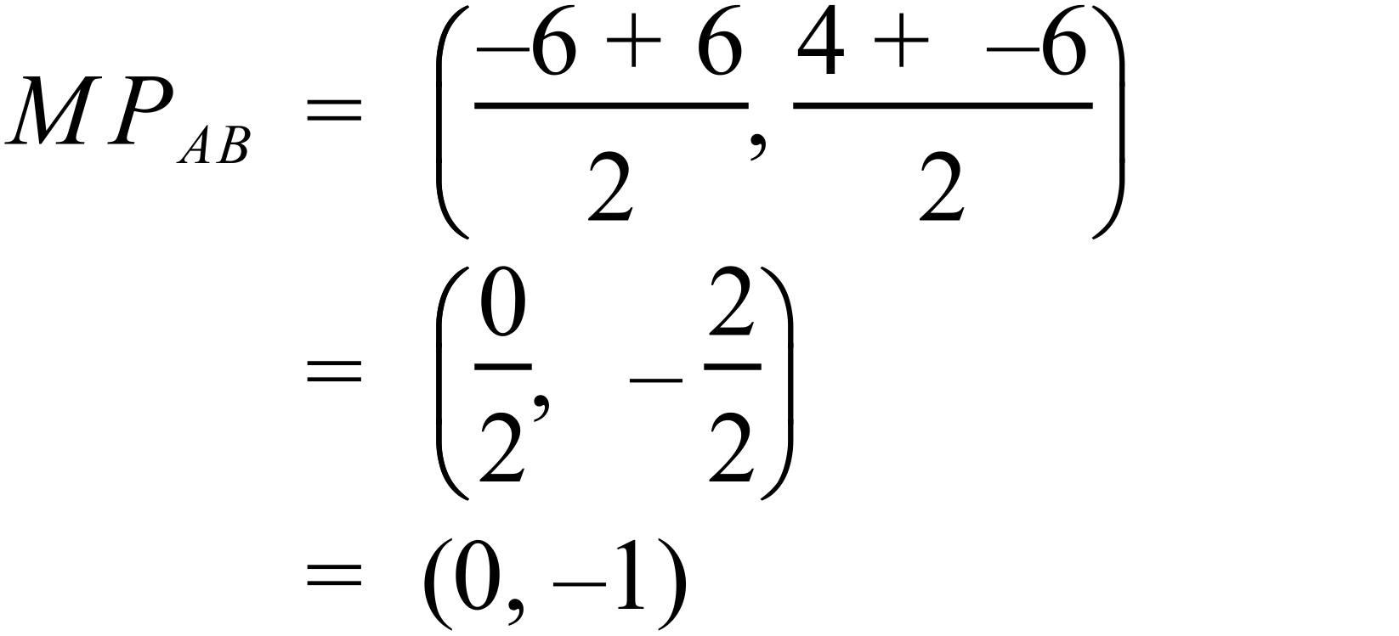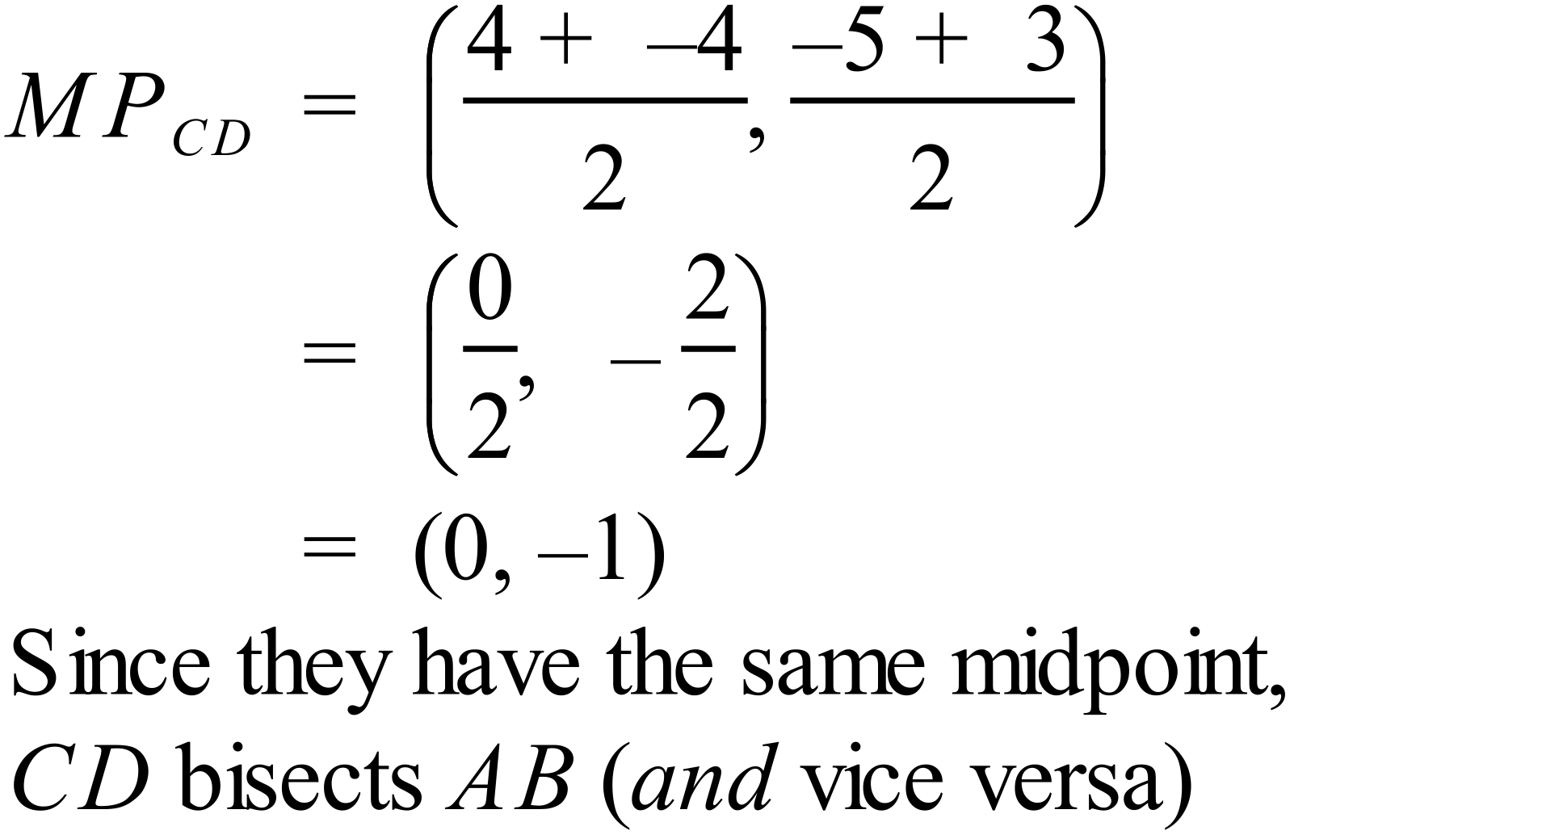 |  | Working required to show bisection
 | 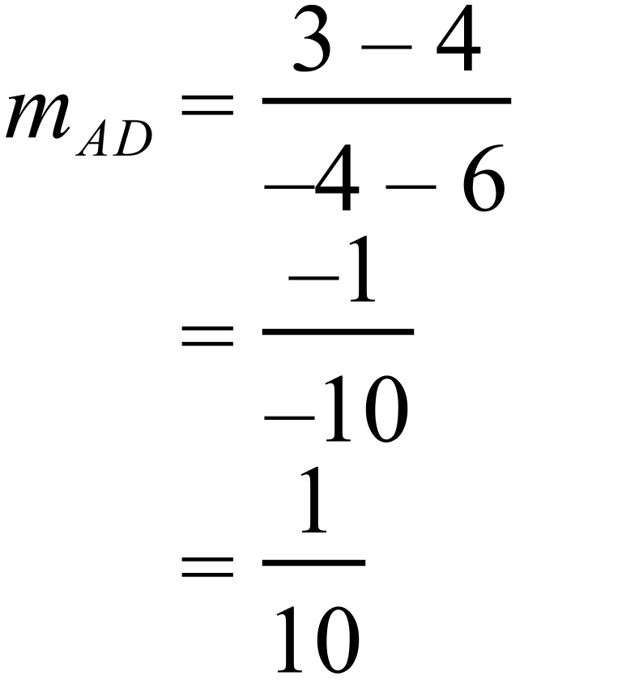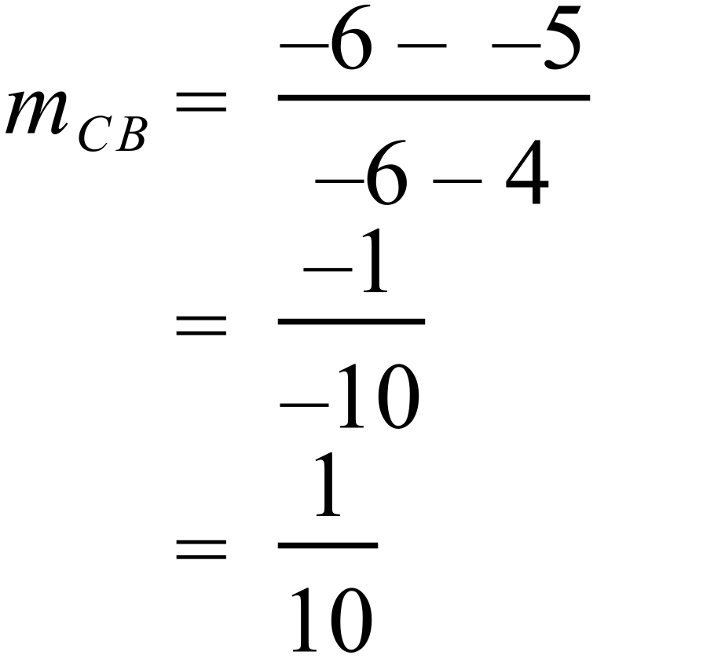  Since the gradients are the same, the lines are parallel. |  | Working required to show parallel lines

Year 9 |  | Coordinate Geometry | Calculator Allowed
Section 2 Multiple Choice Section
ANSWERS
No. | WORKING |  |  | ANSWER
 | 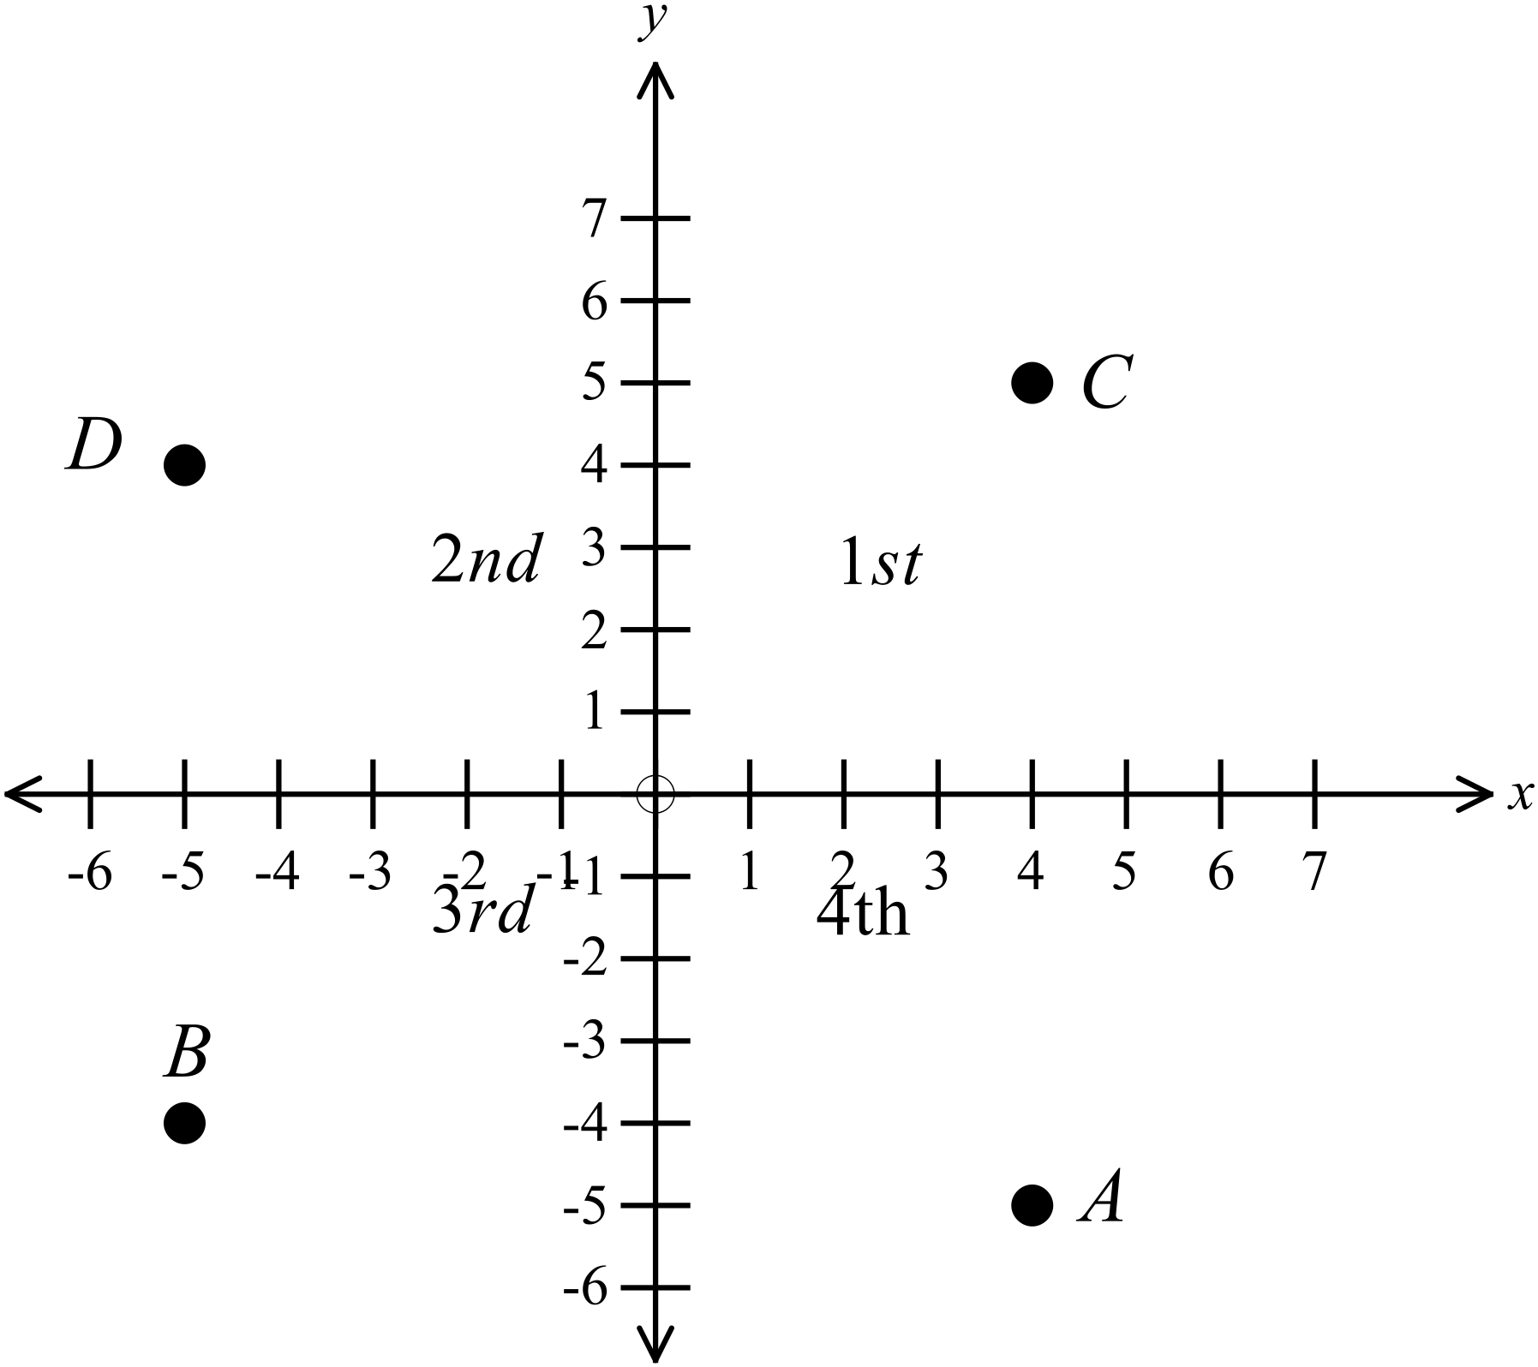  B is in 3rd quadrant |  |  | B
 | A could have coordinates (4, -5). |  |  | A
 | Midpoint of (9, 4) and (5, 0)  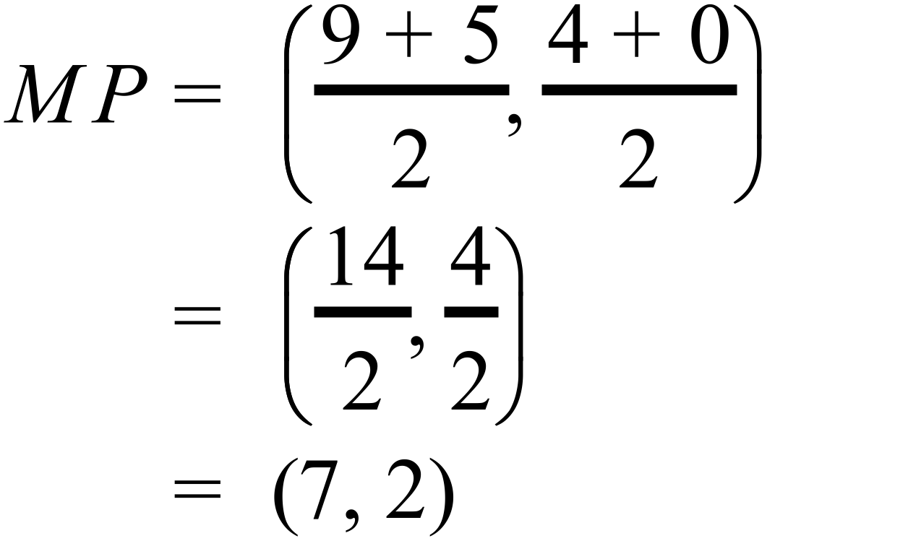 |  |  | C
 | 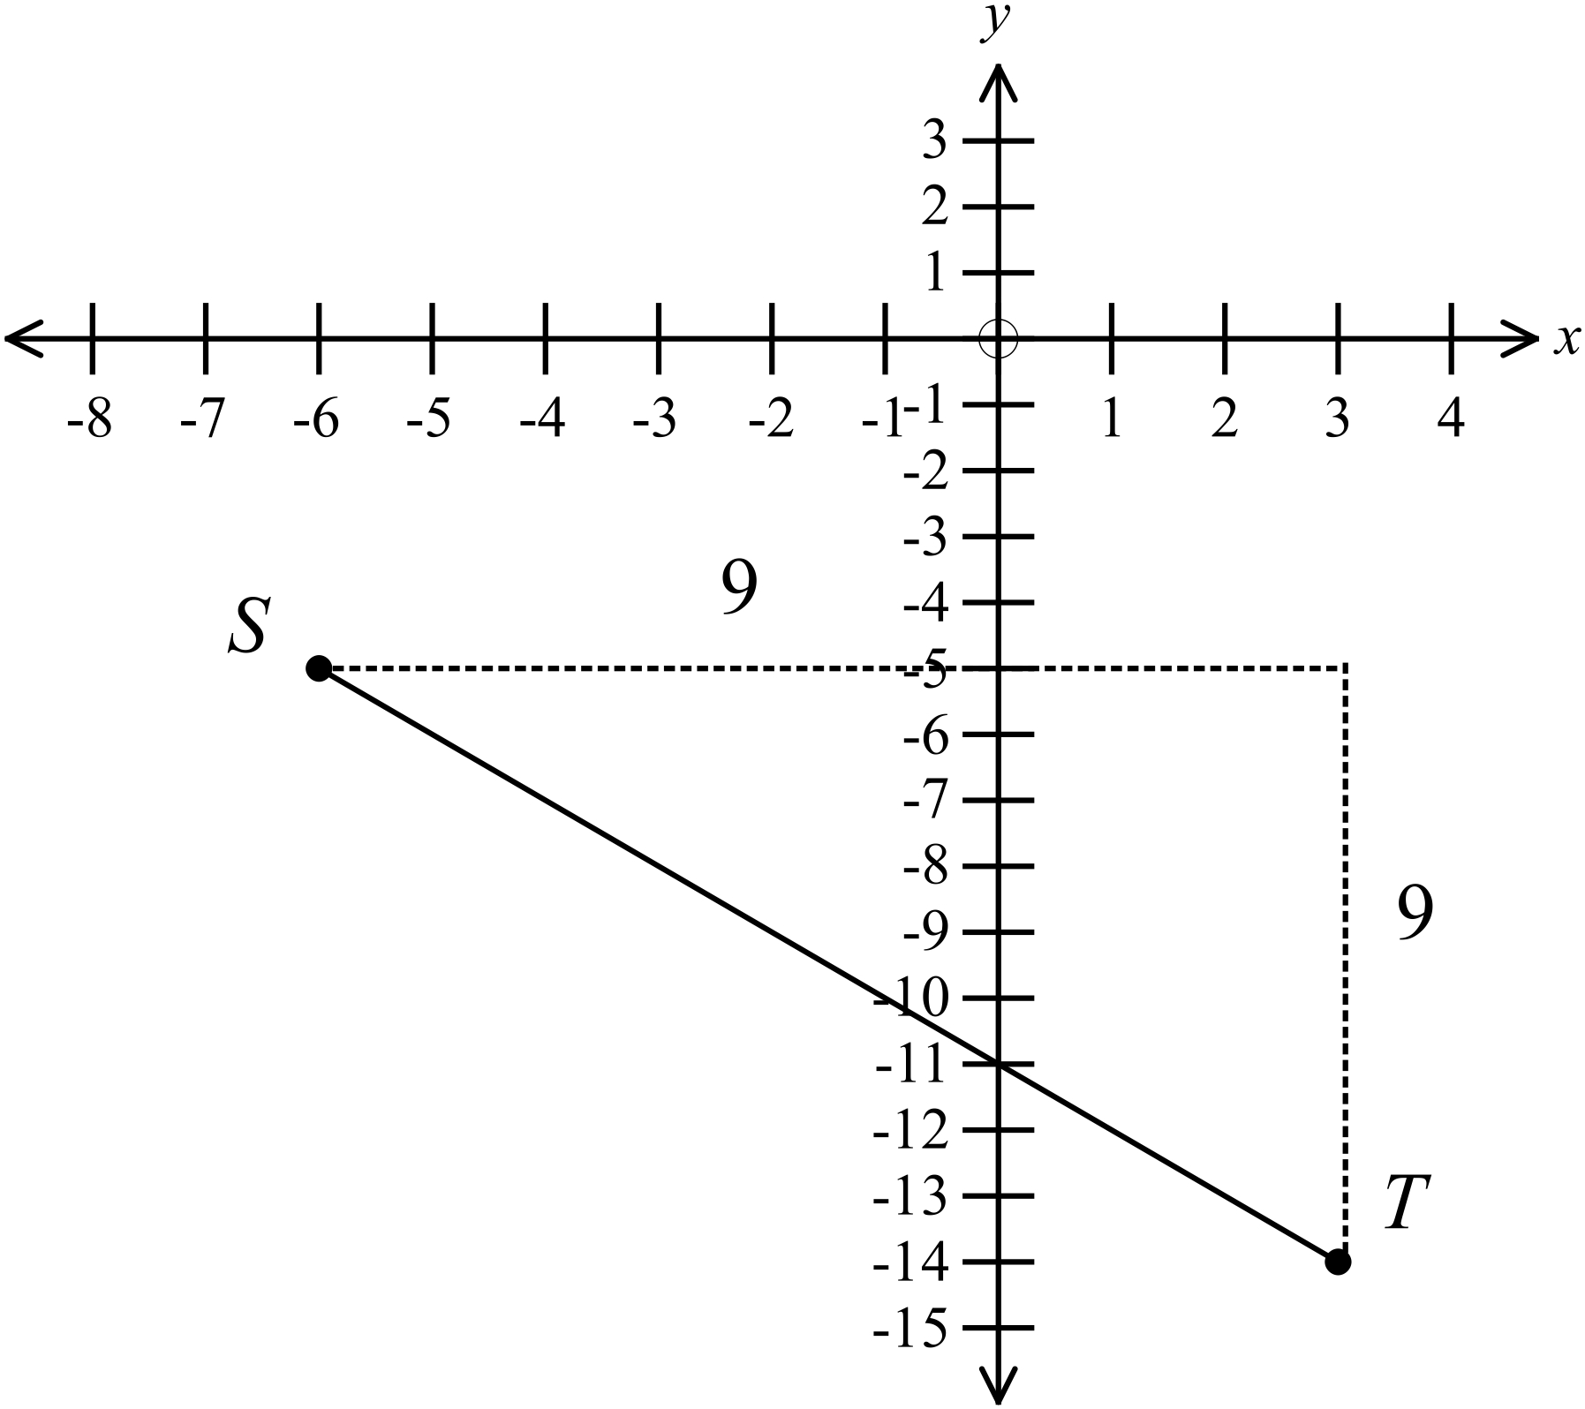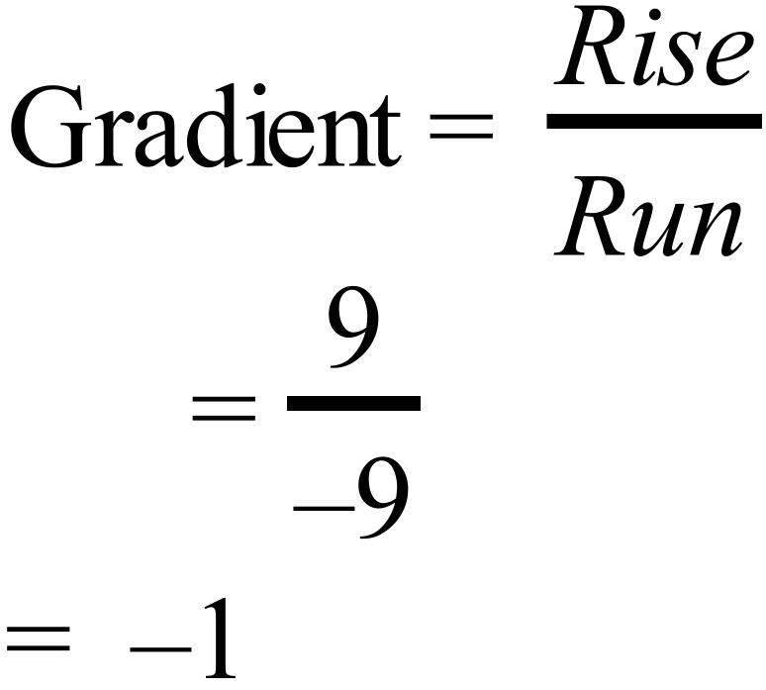 |  |  | B
 | 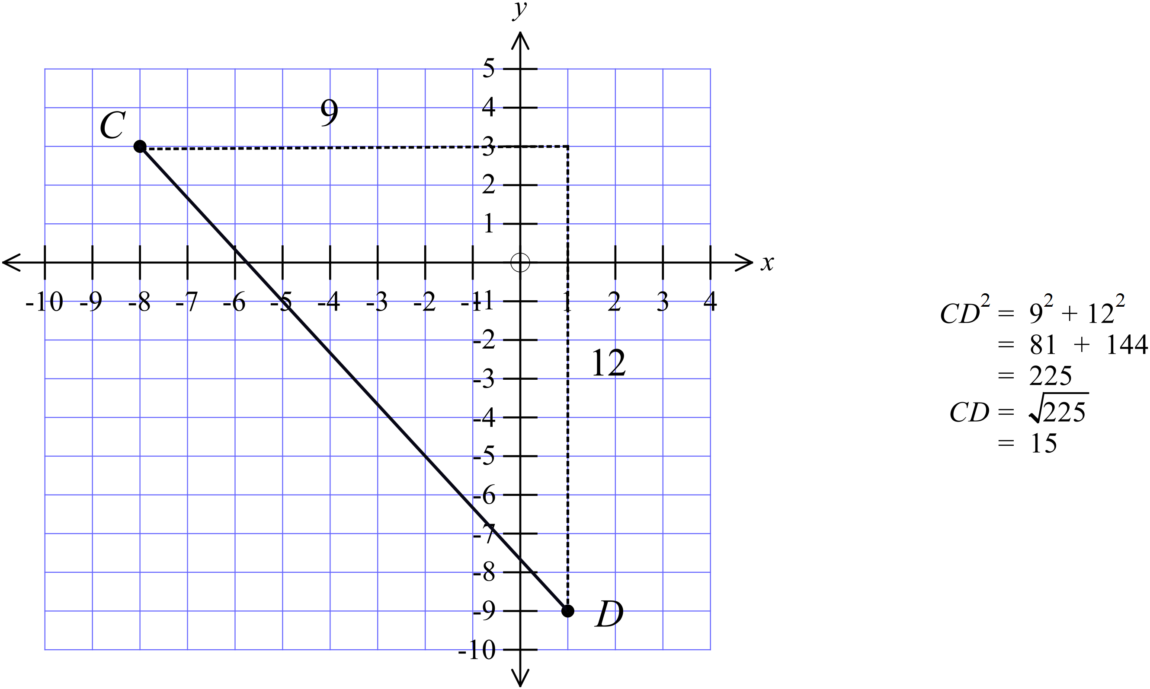 |  |  | D
 | 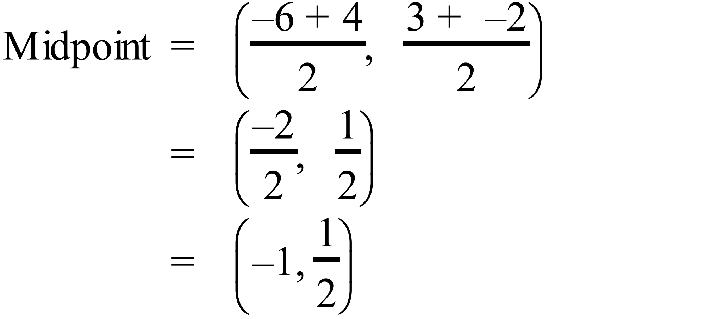 |  |  | D
 | 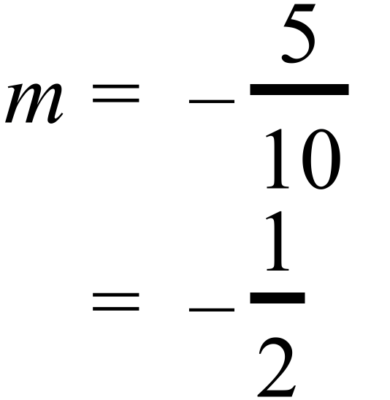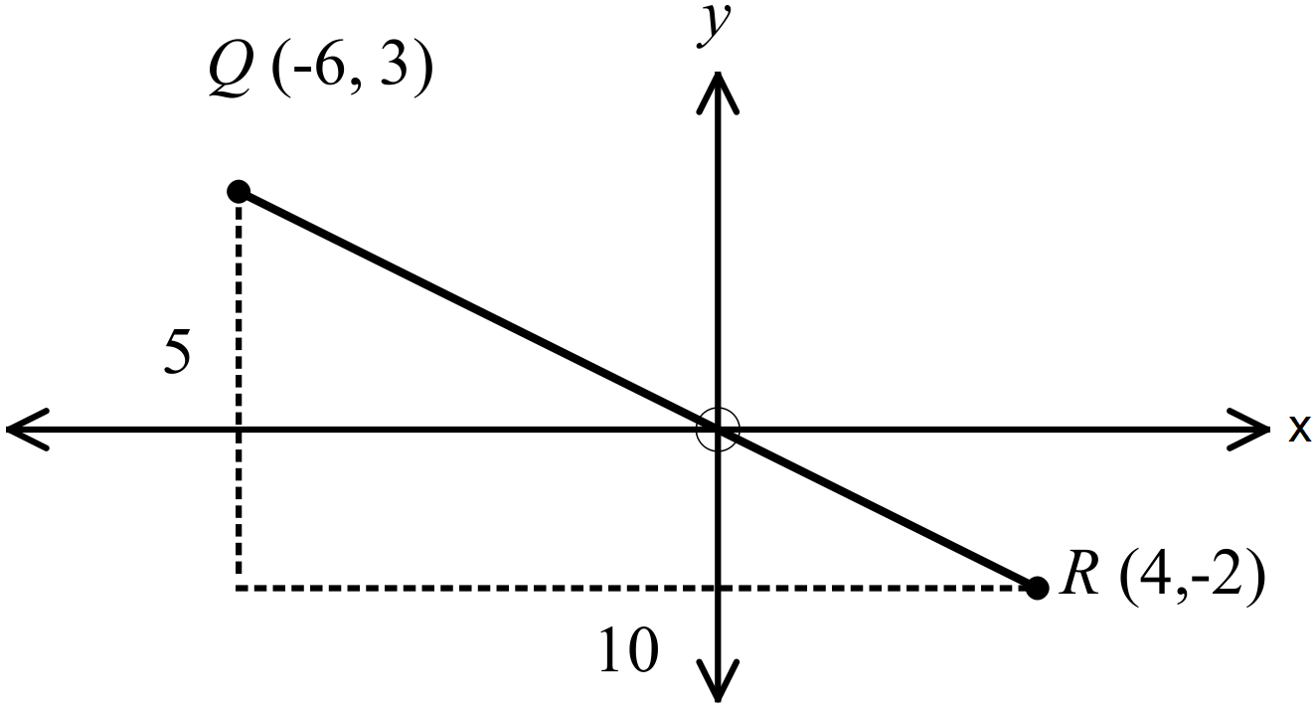 |  |  | B
 | 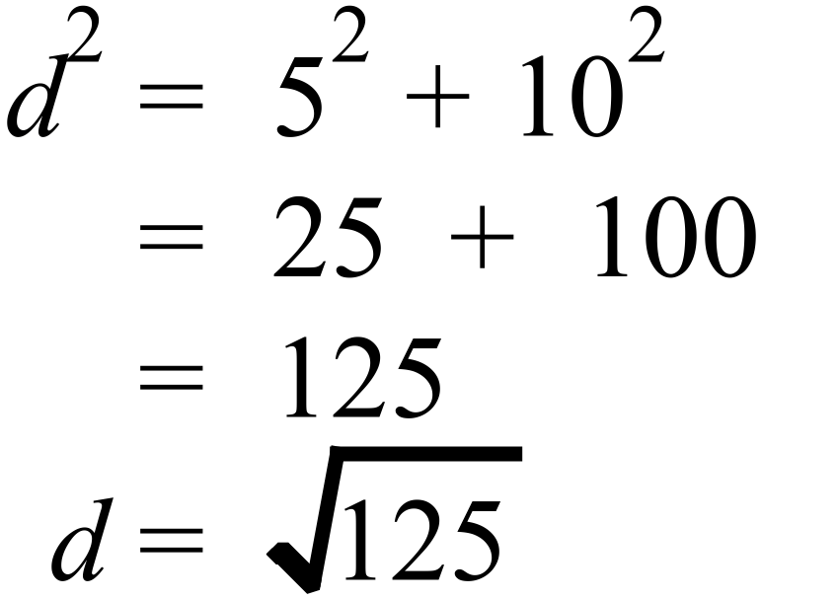 |  |  | B
 | D(6, -7) and E(-3, 2).  Rise = 2- -1 =2+1 = 3  Run = -3-3 = -6  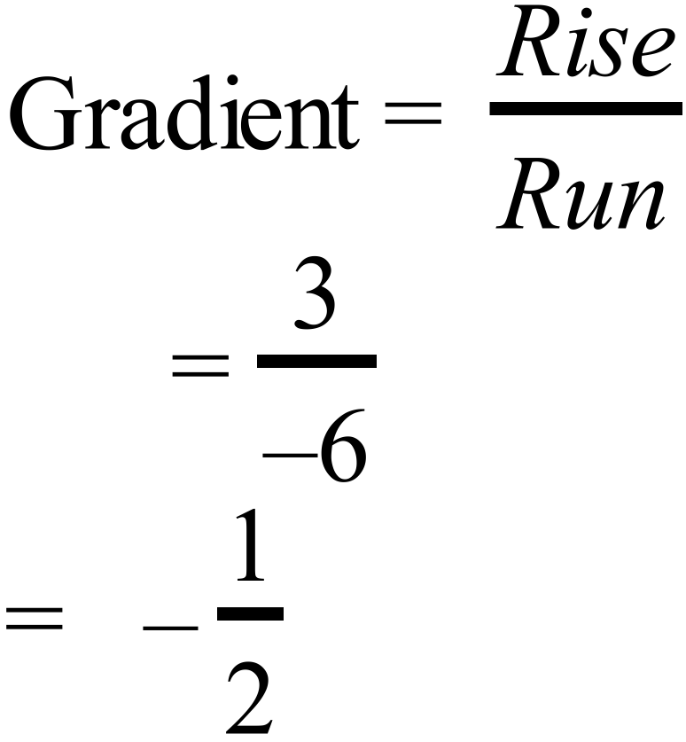 |  |  | C
 | G(-2, -5) and H(-6, 7).  Rise = 7- -5 =7+5 = 12  Run = -6- -2 = -6+2 = -4  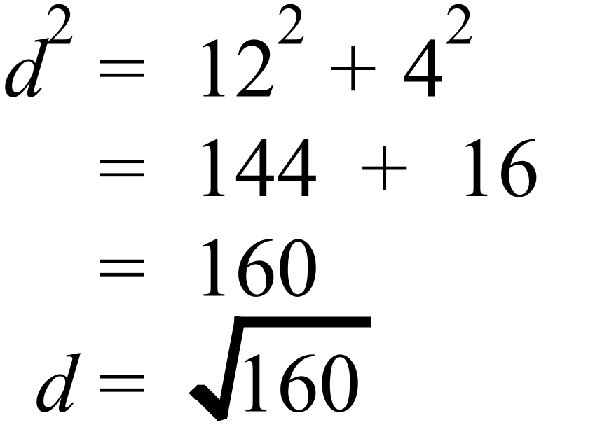 |  |  | C
 |  |  |  | A
 | 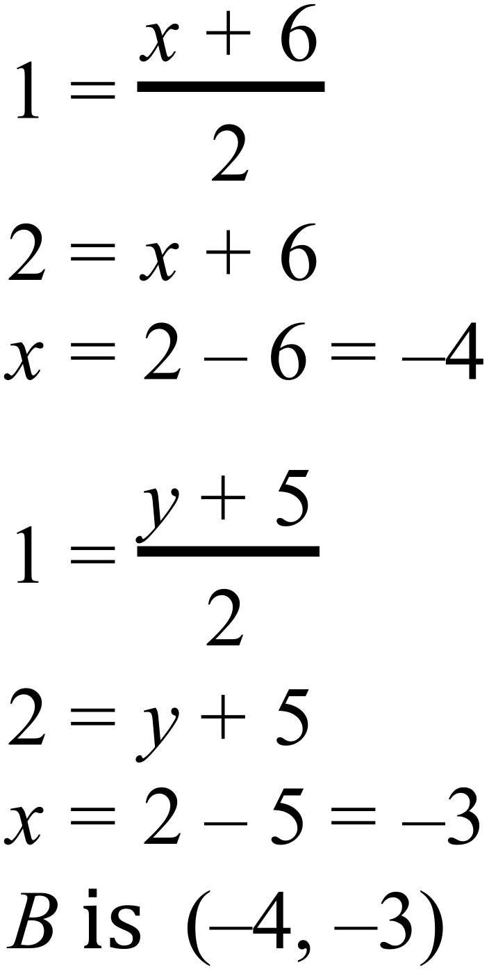 |  |  | A
 | 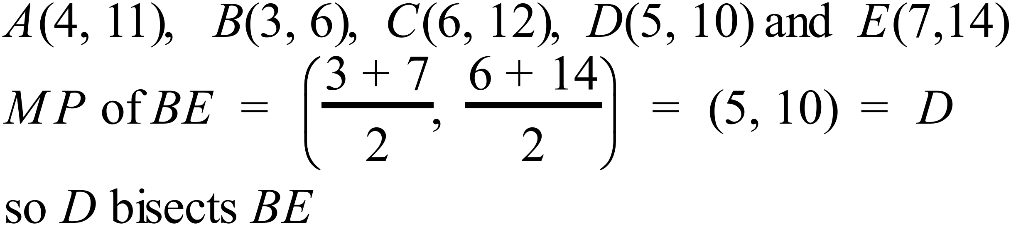 |  |  | D
 | 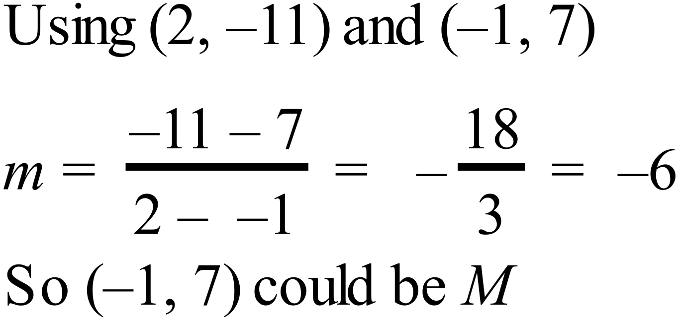 |  |  | A
 | 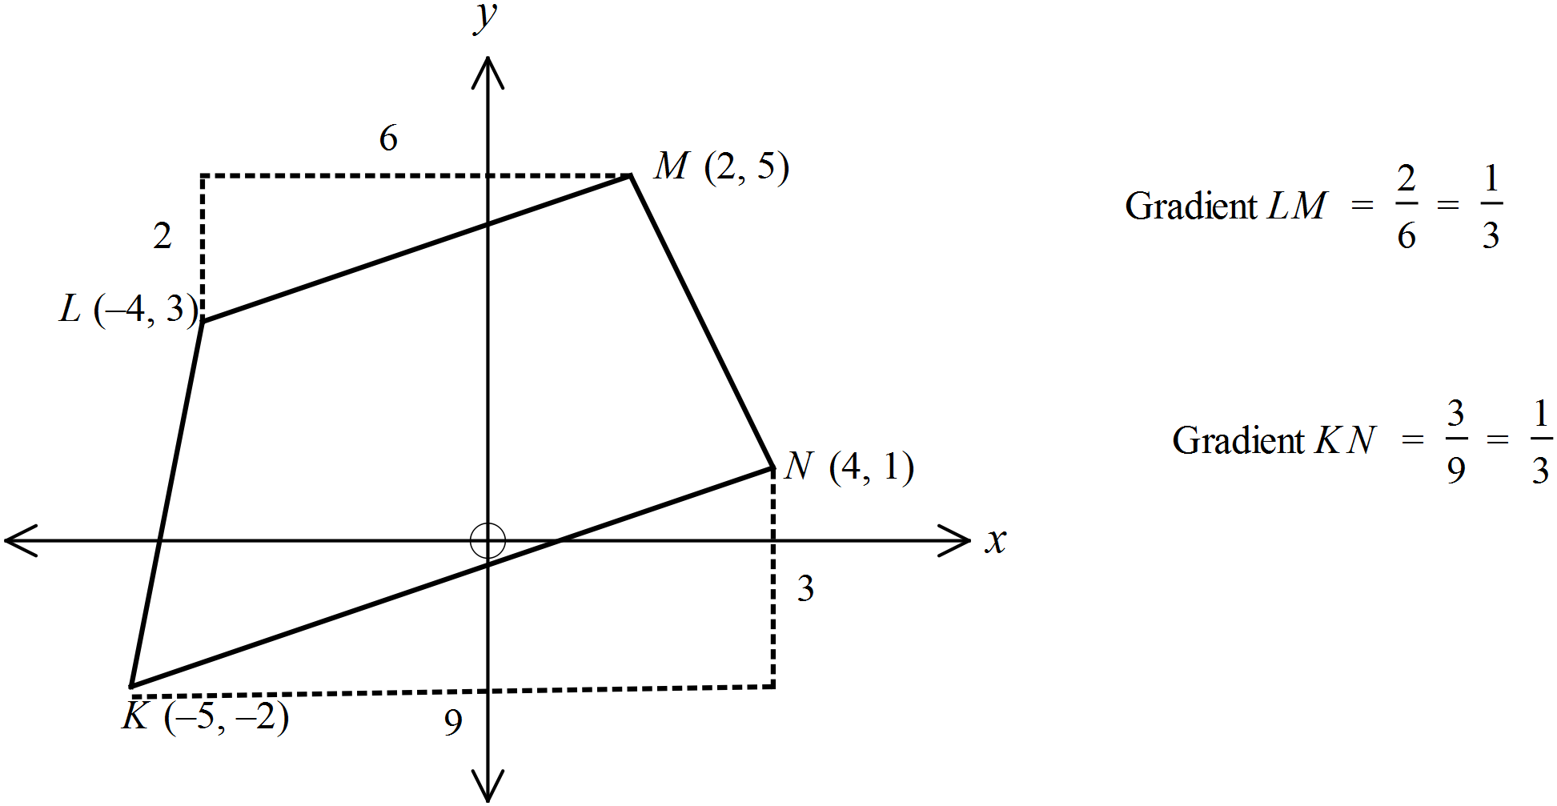 |  |  | C

Multiple Choice Answer Sheet
Coordinate Geometry
Name _______ANSWERS_______________________________
9Completely fill the response oval representing the most correct answer.

1. A B C D
2. A B C D
3. A B C D
4. A B C D
5. A B C D
6. A B C D
7. A B C D
8. A B C D
9. A B C D
10. A B C D
11. A B C D
12. A B C D
13. A B C D
14. A B C D
15. A B C D

